# Lab 2: It's All About the Payload

CosmicWorks has years of product,chal customer, and sales data that they exported to an Azure storage account. They want to load this data into the Azure Cosmos DB account for a future migration of their e-Commerce site to Azure, but also for the POC of the chat interface. They also want to load the data into Azure Cognitive Search so that they can search for product and account information by the vector embeddings.

One critical component of the magic that makes the CosmicWorks chat interface work is the ability to search for products and accounts by their vector embeddings. When a user types a question into the chat interface, we need to create a vector embedding for the question, then search for the most similar vector embeddings of products and accounts, and then return those similar documents. The vector embeddings for products and accounts are stored in a vector database, allowing us to return relevant context documents that get sent to Azure OpenAI's completions endpoint.

CosmicWorks has done some research, and they would like to use Microsoft Semantic Kernel as the framework the code uses to orchestrate calls to the Azure OpenAI embeddings and completions endpoints. They've provided some incomplete starter code to give you an idea of what they are looking for.

**Objective** :

1. Load sample data into CosmosDB using Data Migration tool
2. Create a vector index in Cognitive search.
3. Configure change Feed on the customer and product collections to read the data, generate embeddings using the OpenAI model, and load into the index.
4. Validate the index records.

## Task 1 : Verify product and customer data in the Storage account

1. Open a browser go to <https://portal.azure.com> and sign in with your Azure subscription account.
2. On the Home page, click on the **Resource groups** tile.

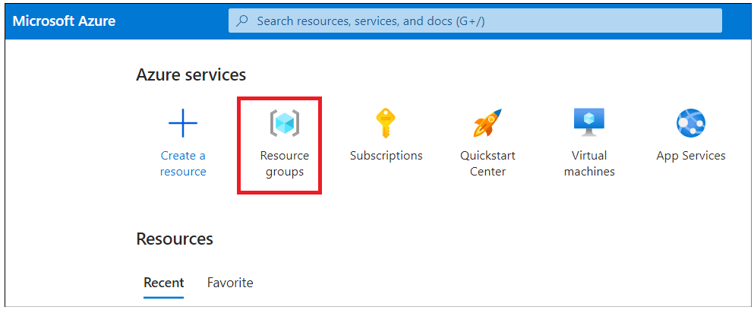

1. Click on your resource group name and then click on **Storage account** name with the list of resources .

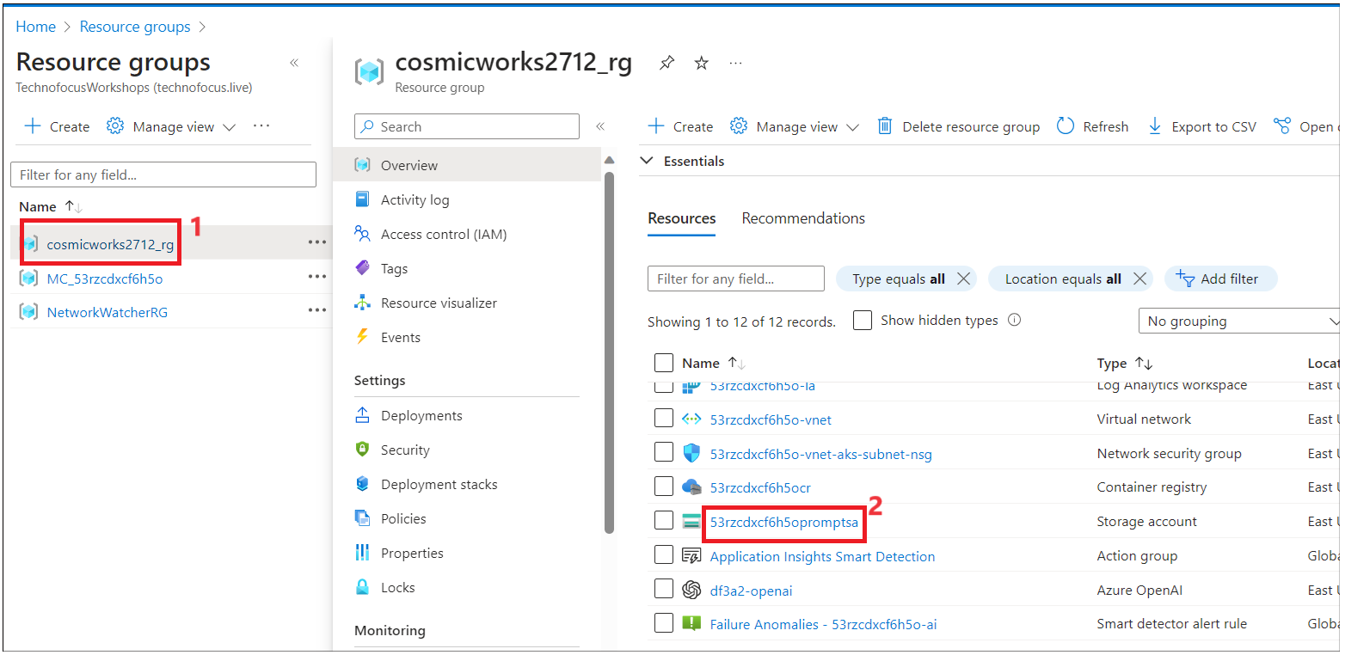

1. Click on **Containers** from left navigation menu and then click on **memory-source** container.

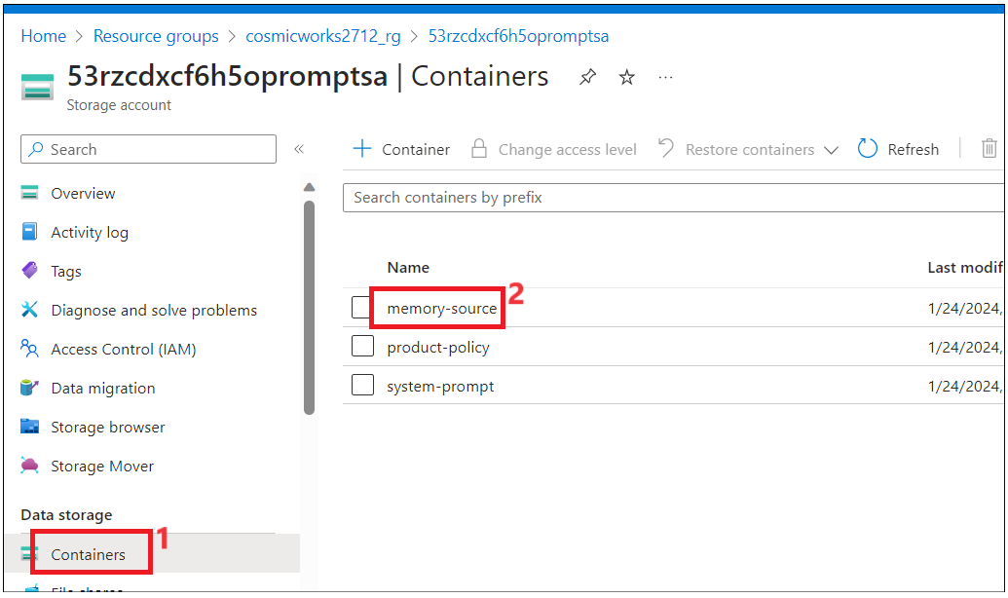

1. Verify that **ACSMemorySourceConfig.json** and **BlobMemorySourceConfig.json** files have been loaded.

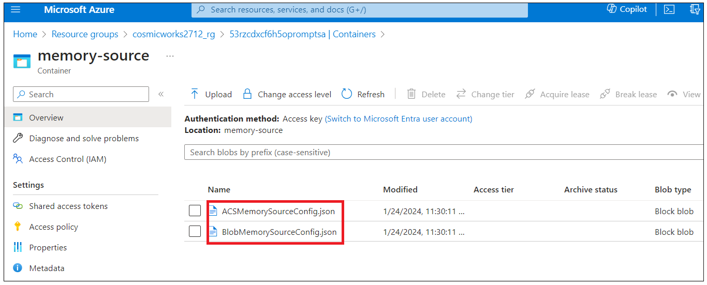

1. Click on **Container**s from top navigation menu as shown in below image.

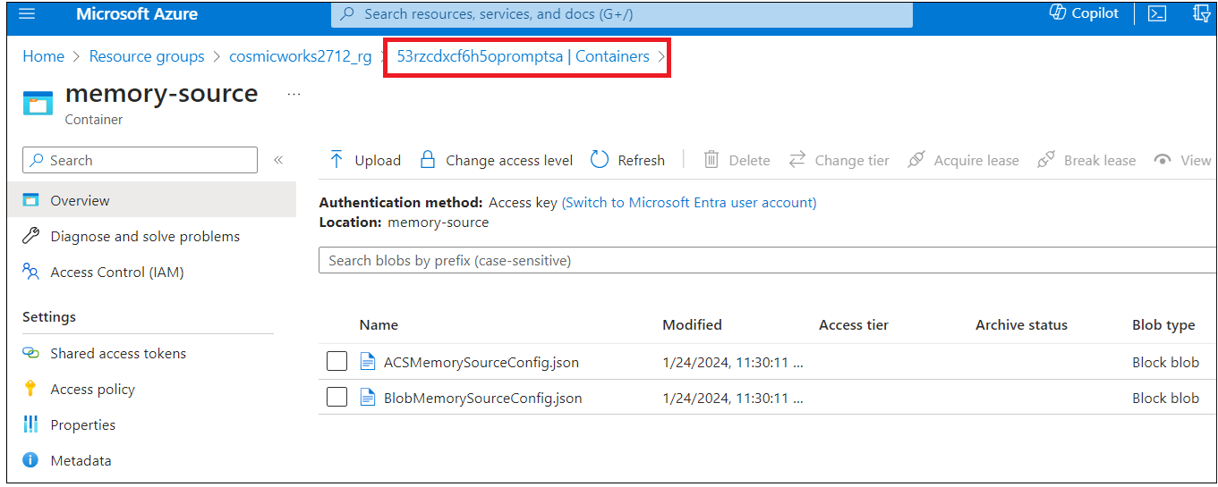

1. Click on **product-policy** container.

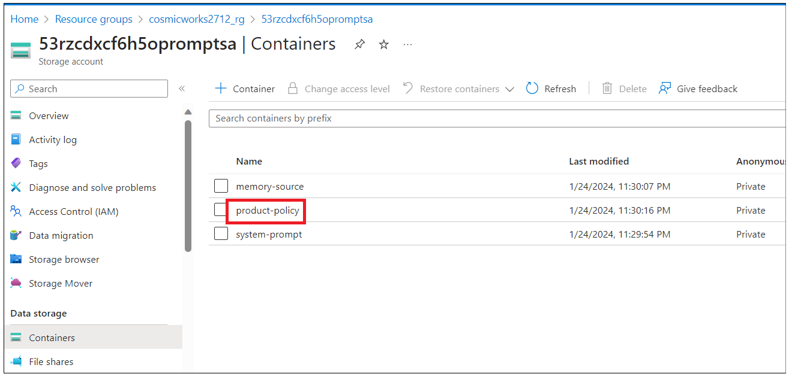

1. Verify that **return-policies.txt** and **shipping-policies.txt** should have been loaded.

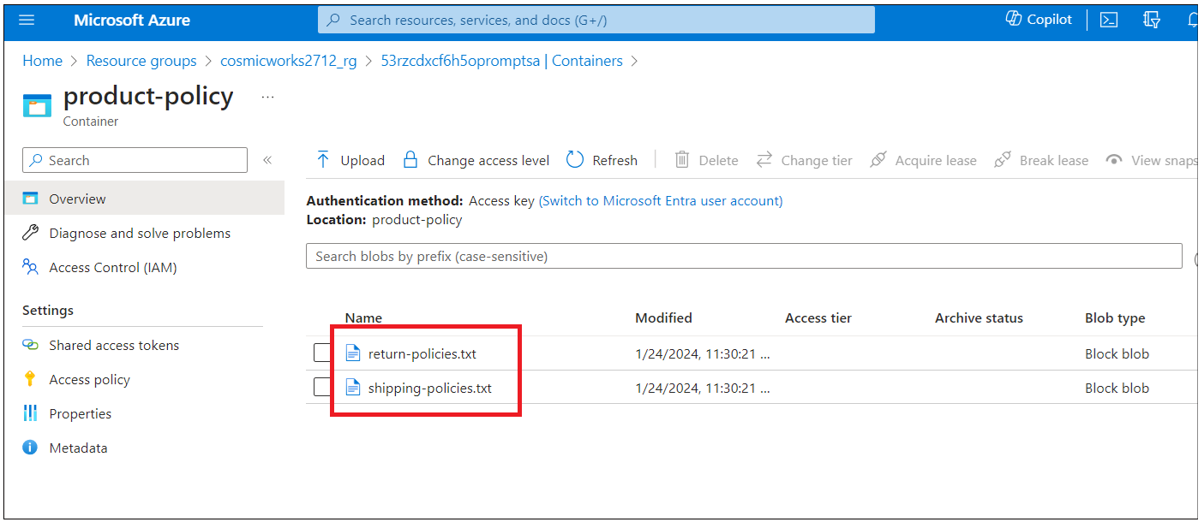

1. Click on **Containers** from top navigation menu.

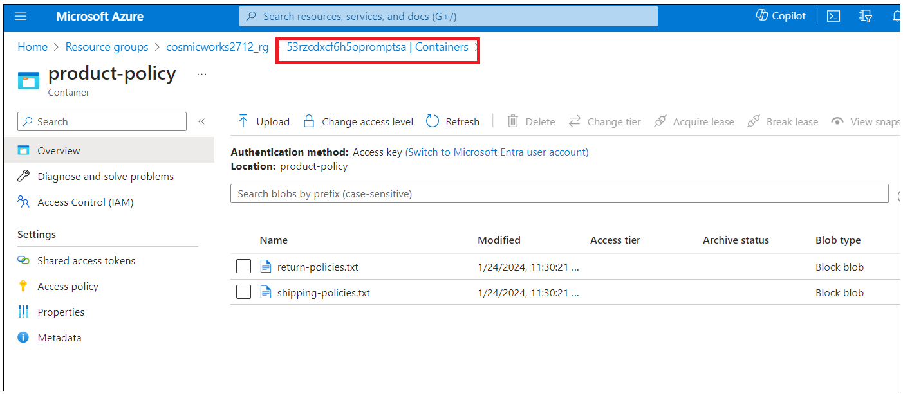

1. Click on **System-prompt** container.

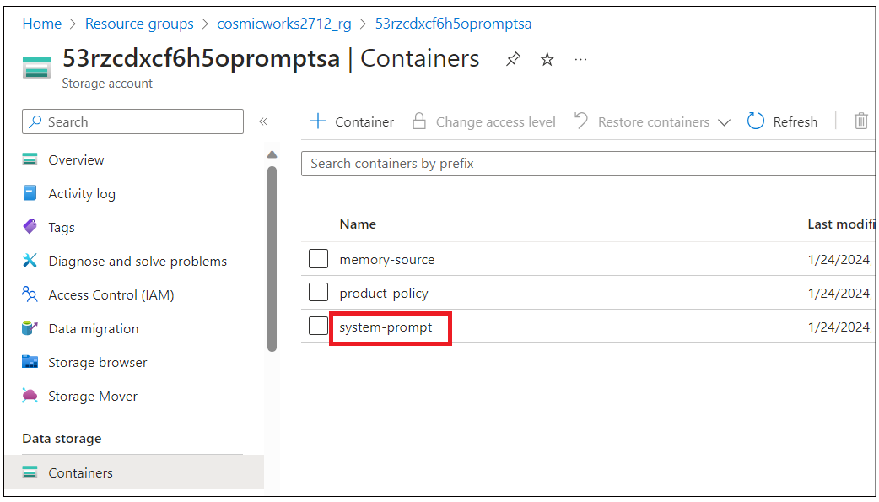

1. Make sure **RetailAssistant** and **Summarizer** folders should be added to the container.

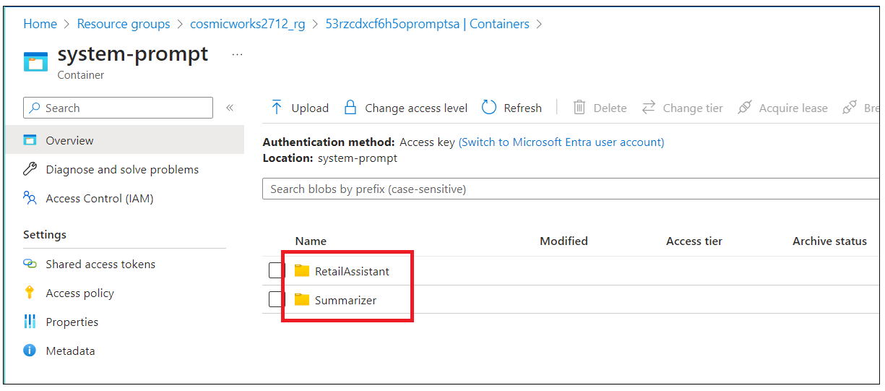

1. Click on **RetailAssisitant** folder and you should **Default.txt** and **Limited.txt** files.

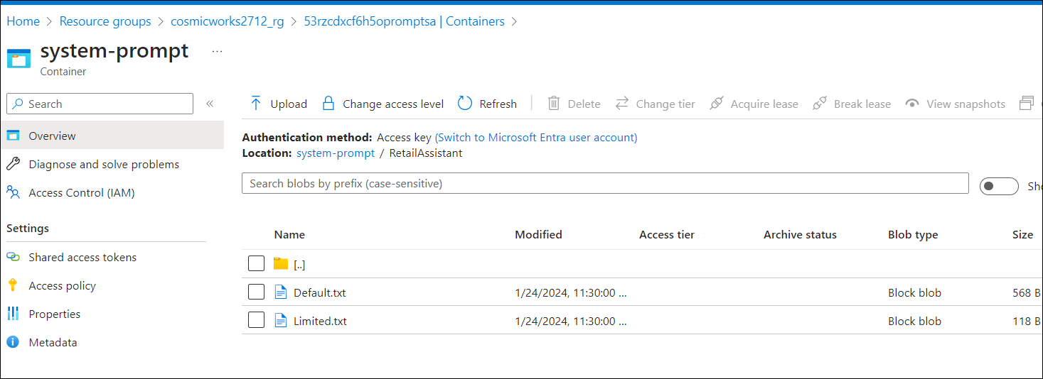

1. Navigate the **Summarizer** folder and you should see **TwoWords.txt** file.

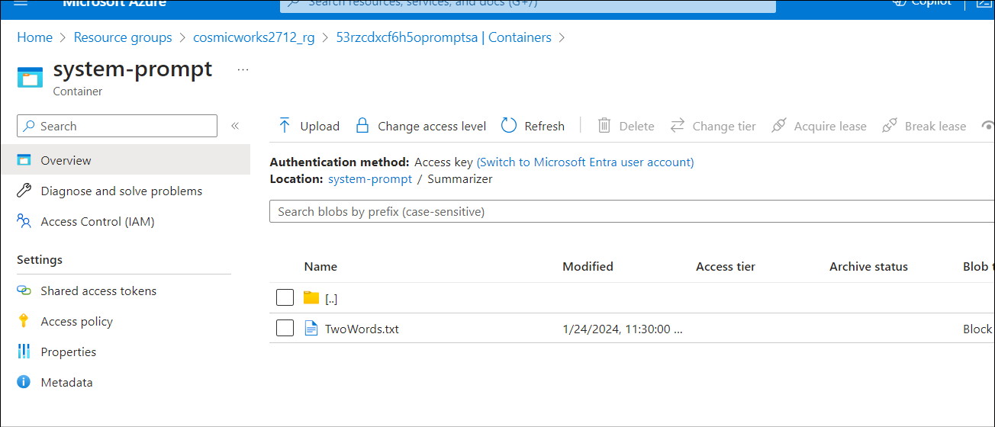

## Task 2 : Configure and run Data migration tool

1. Switch back to **Azure portal** tab and click on your resource group name and then click on **Azure Cosmos DB name**.

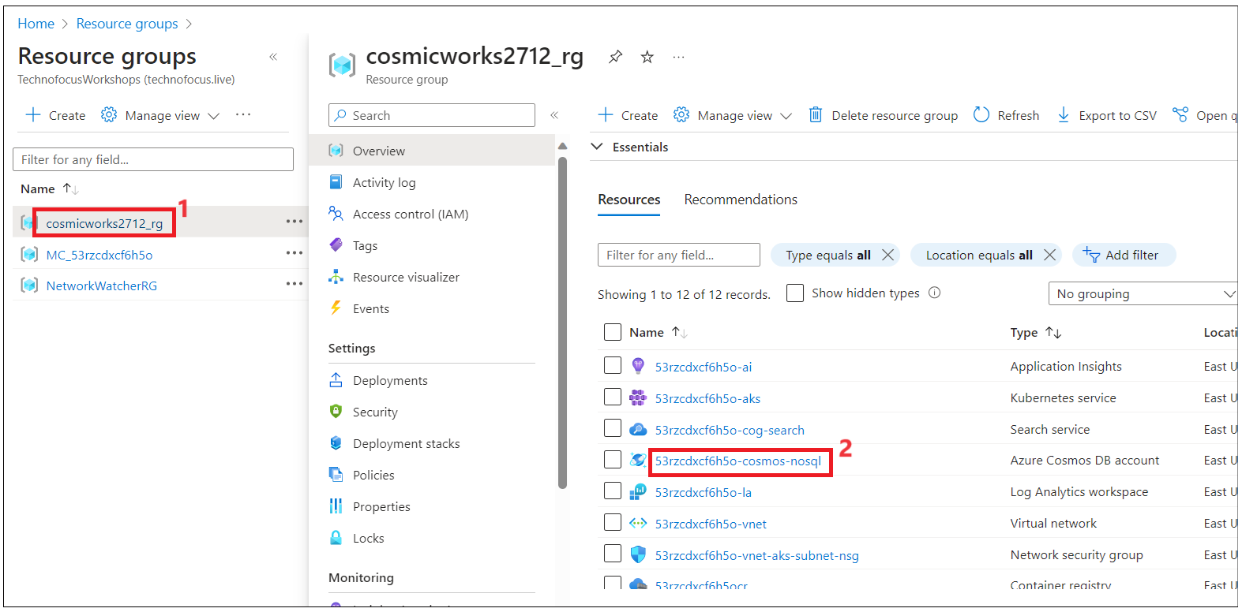

1. Click on **Keys** form left navigation menu and copy **PRIMARY CONNECTION STRING** value to a Notepad to use in **migrationsettings.json** file in next steps.

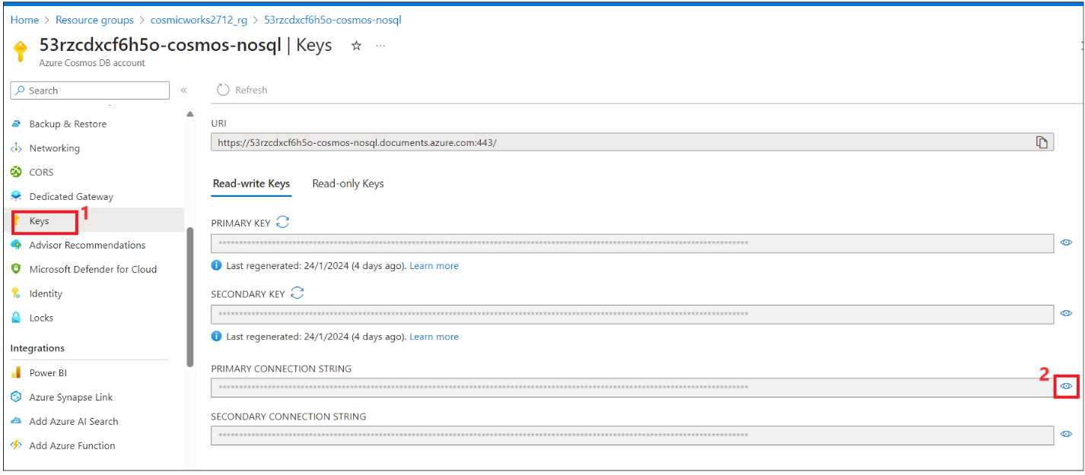

1. Go to Windows explorer - **C:\ Labfiles\starter-artifacts\code\VectorSearchAiAssistant** and open **migrationsettings.template.json** in **Visual studio code.**

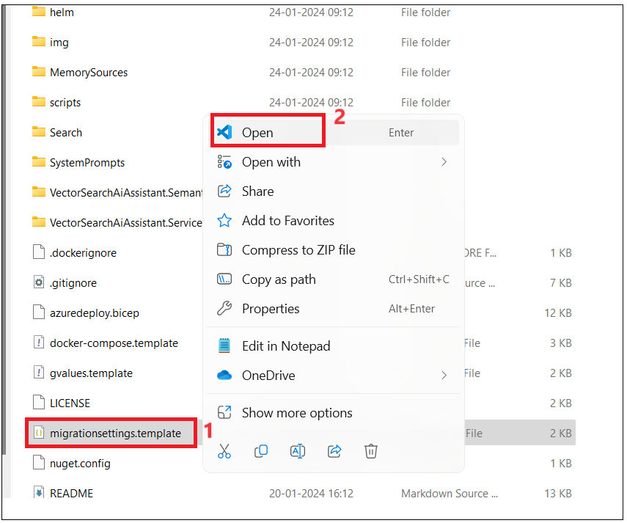

1. Click on **Open**.

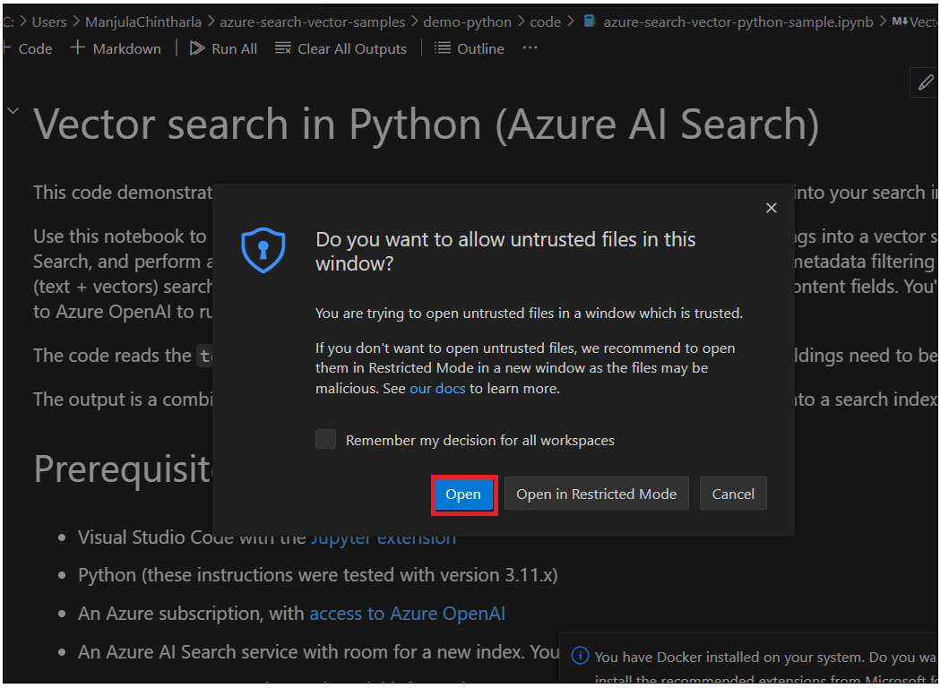

1. Copy the content to replace the code in the dtm file in the next step.

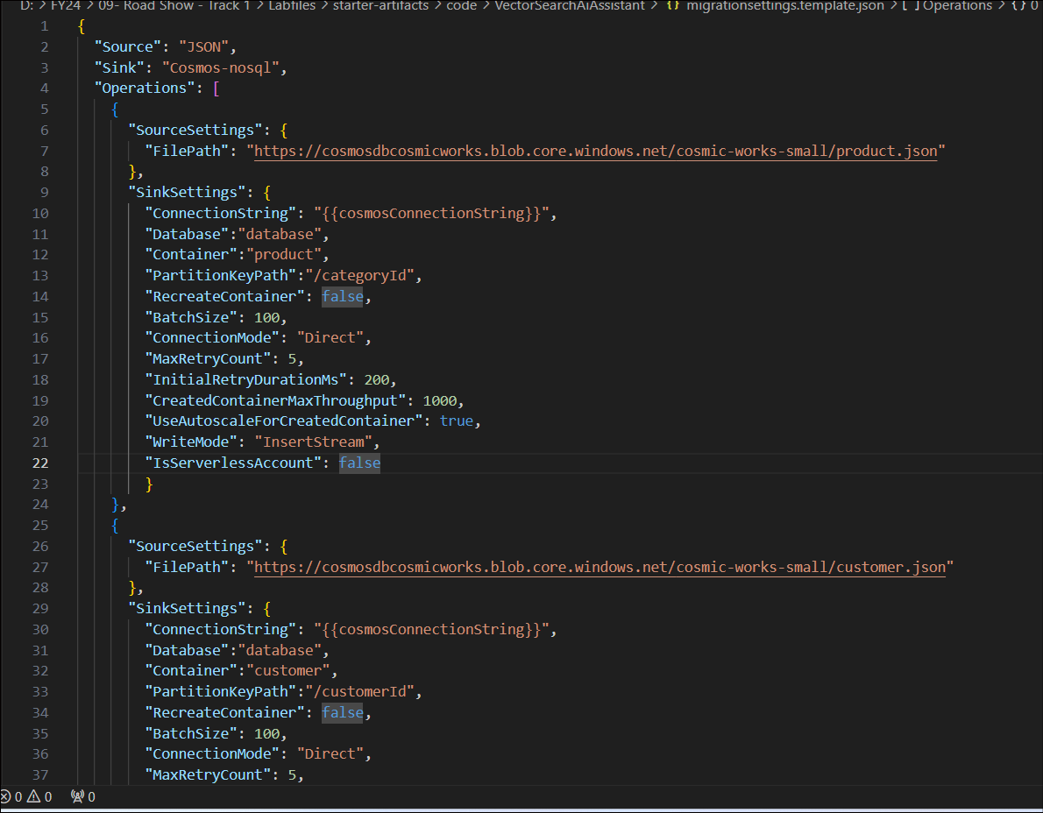

1. Go to **C:\Labfiles\dmt-2.1.4-win-x64\windows-package** and open **migrationsettings.json** file in **Visual studio code**.

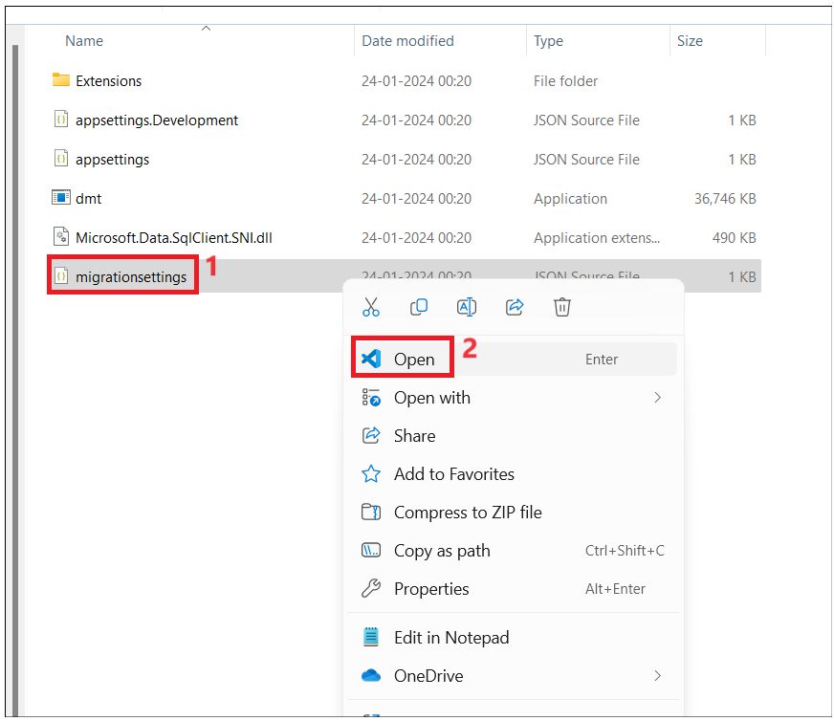

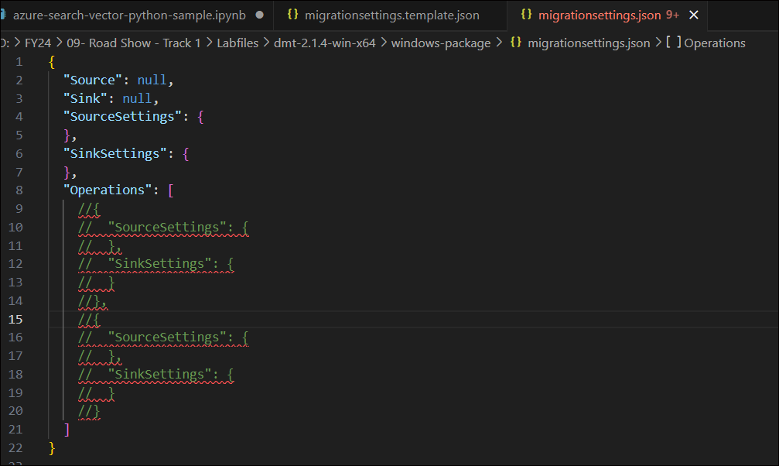

1. Replace the content of **migrationsettings.json** with the content of **migrationsettings.template.json** which was copied in Step 3 and save the file.

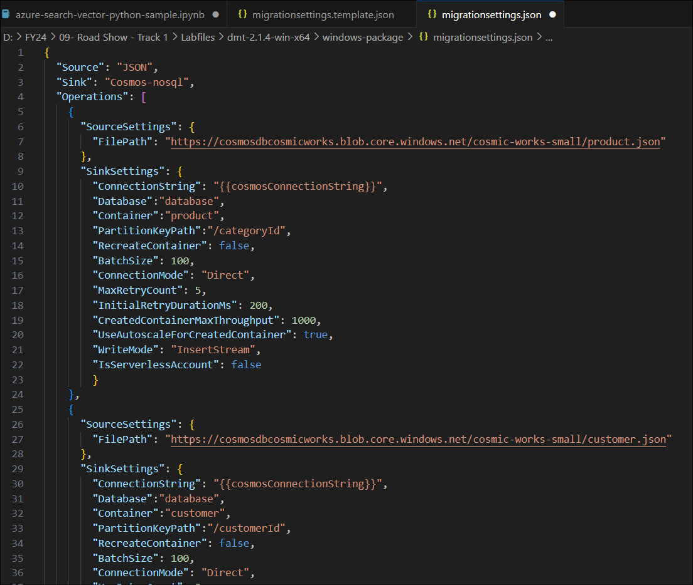

1. Replace the **Connectionstring** value with the **PRIMARY CONNECTION STRING** of Cosmos DB, which was copied in Step 3, and save the file.

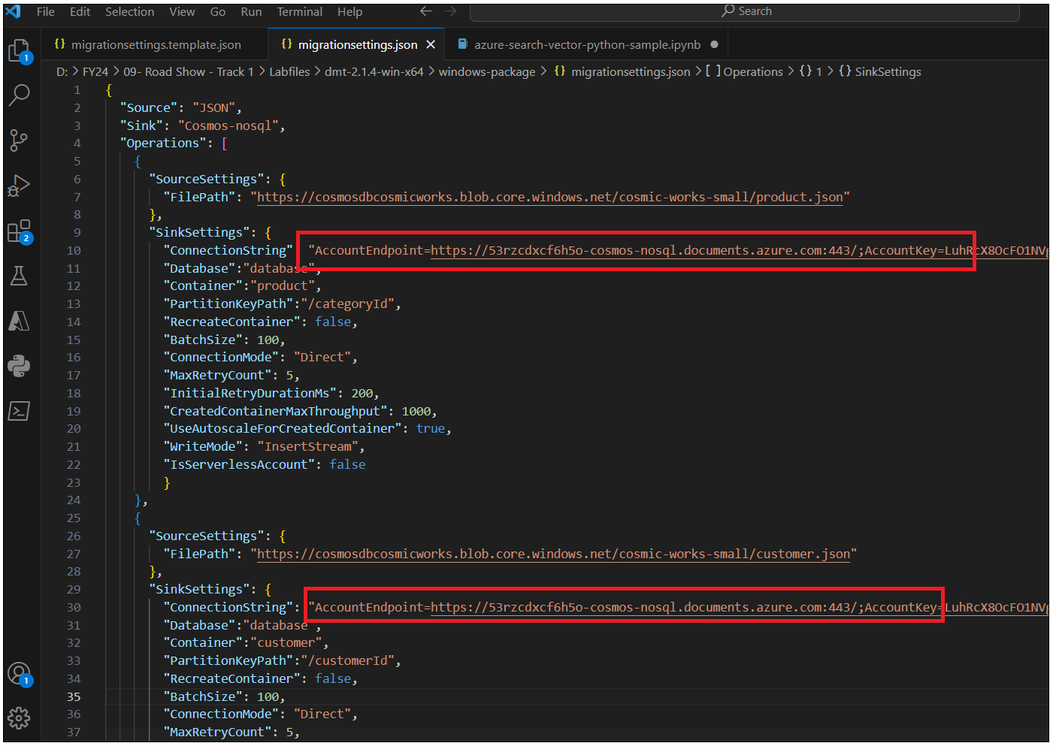

1. From VM’s start menu open **Power Shell** as admin and run **cd “C:\Labfiles\dmt-2.1.4-win-x64\windows-package”**

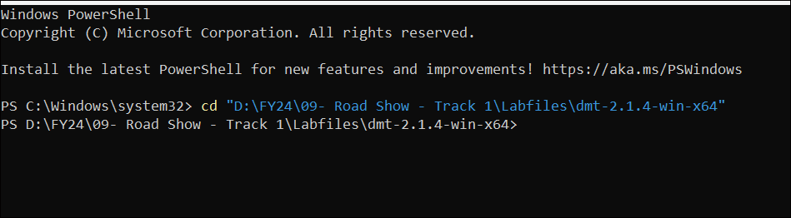

1. Run az login command. This will open the default browser to sign in. Sign in with your Azure subscription account.

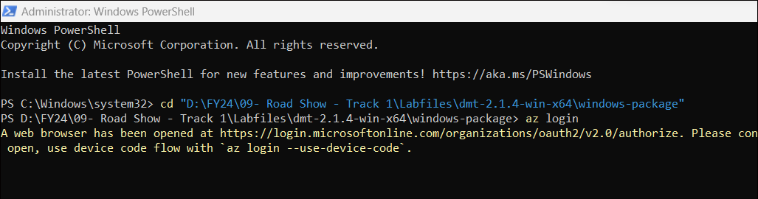

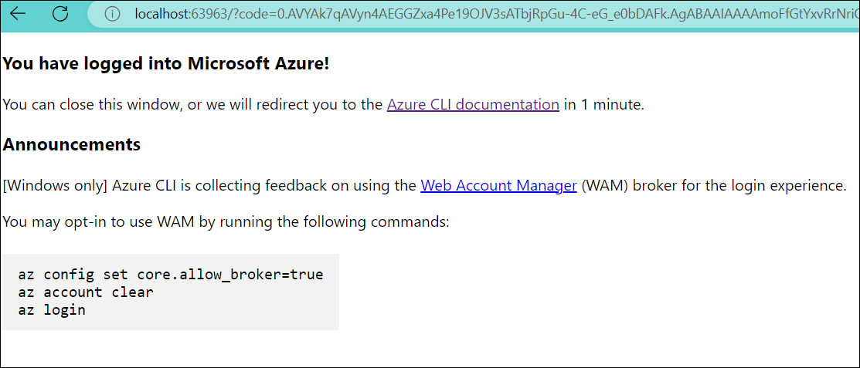

1. Go back to **PowerShell** and run the below command. This will load the document/ data located in the blob storage account provided by Cosmic Works and then load that into the customers and products container of Cosmos This will take a few min

./dmt

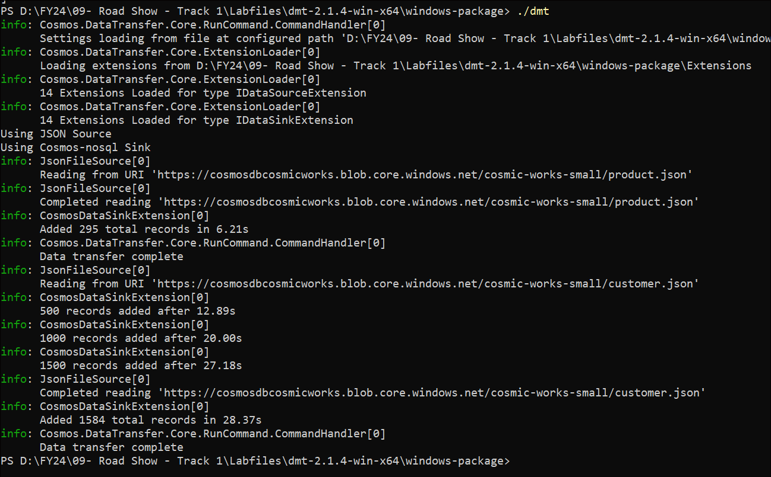

1. After the Data transfer is complete, switch back to the **Azure portal** and click on the **Azure** **Cosmos DB account** name.

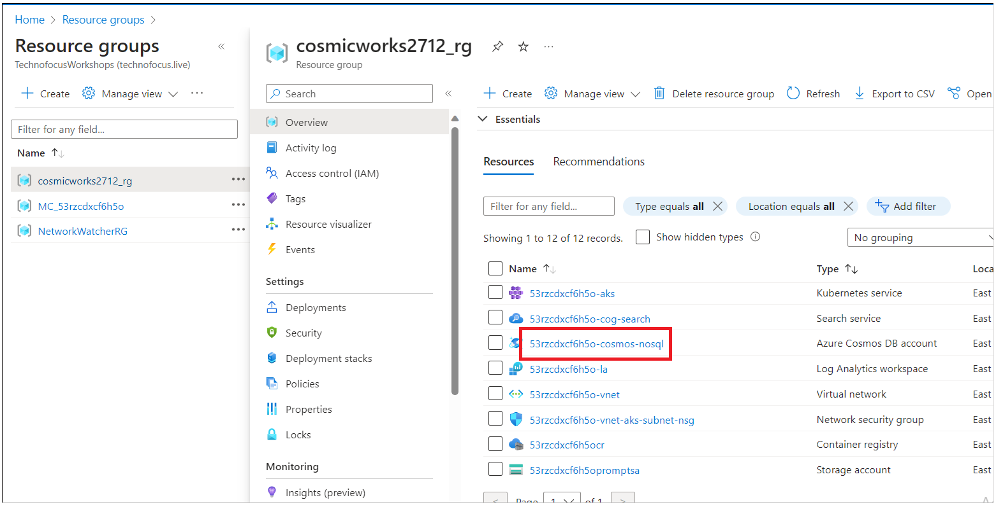

1. Click on **Data Explorer** from left navigation menu. Expand **Data-> database -> customer ->Items.** You should see customers data items now.

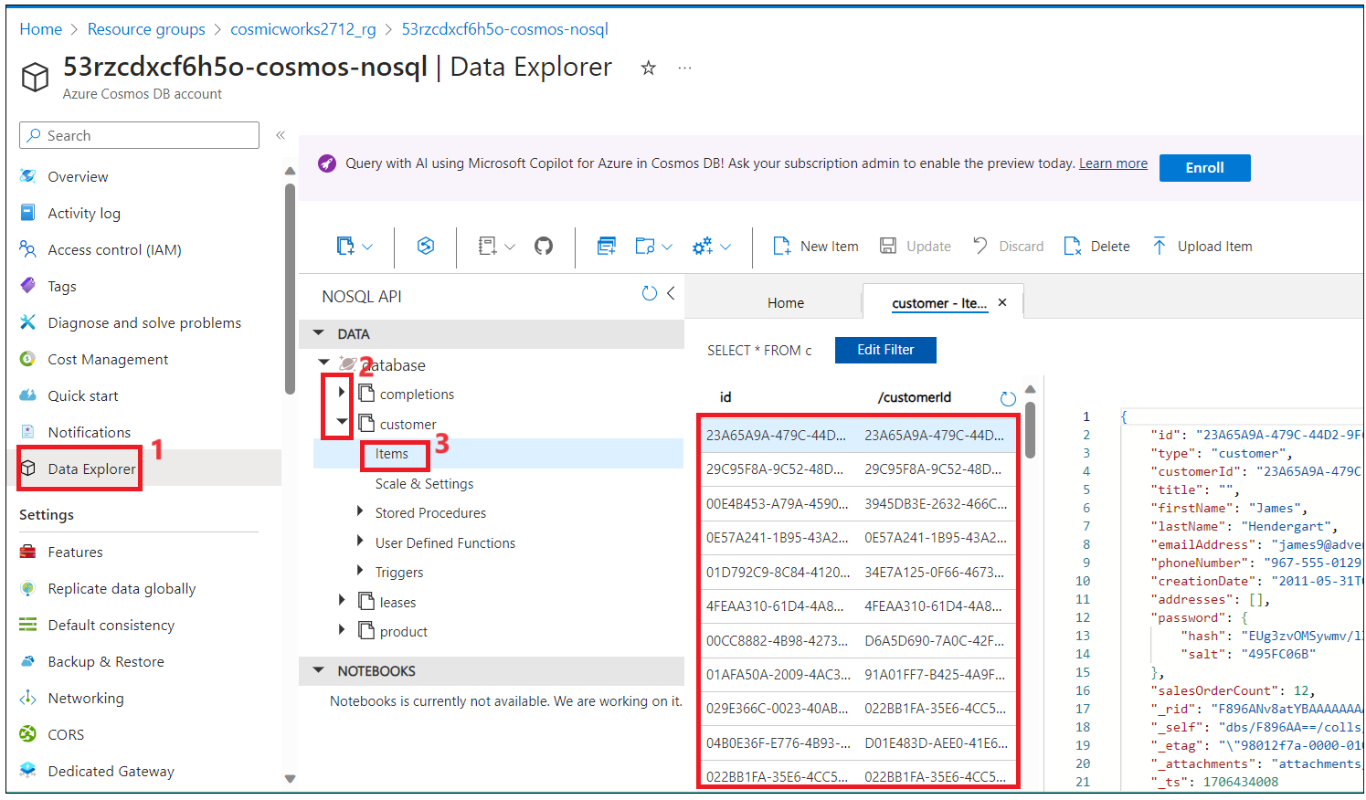

1. Expand product container and check items. You should see list of loaded product items into the product container.

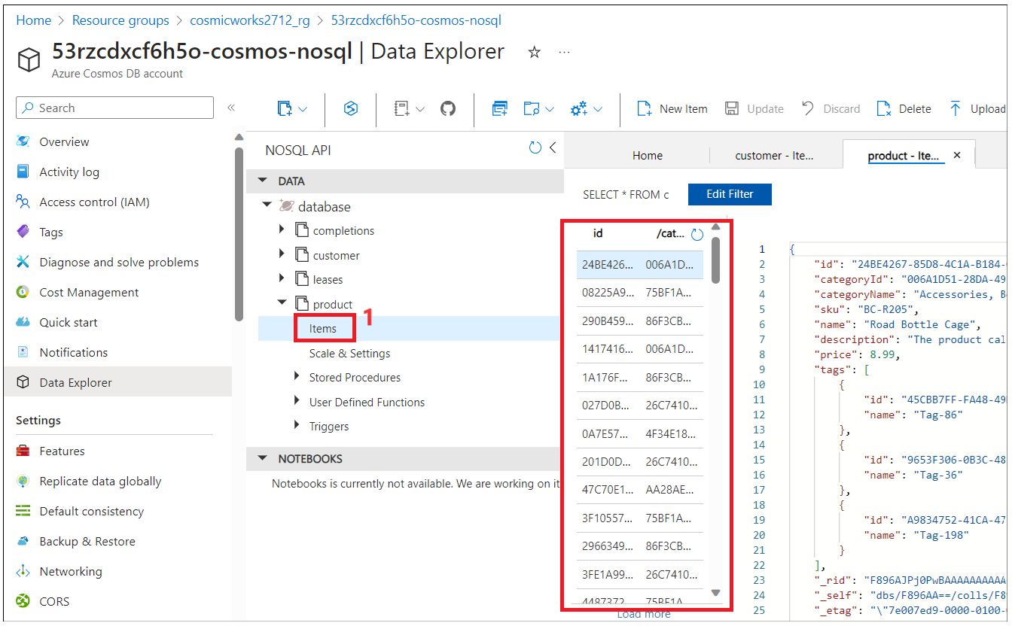

## Task 3 : Confgure CosmosDbServices to load data.

1. Configure change feed on the customer and product collections to read data, generate embeddings using the OpenAI model, and load into the vector index.
2. Switch back to **Visual Studio** 2022 and open **CosmosDbService.cs** file from **VectorSearchAiAssistant.Service\Services.**

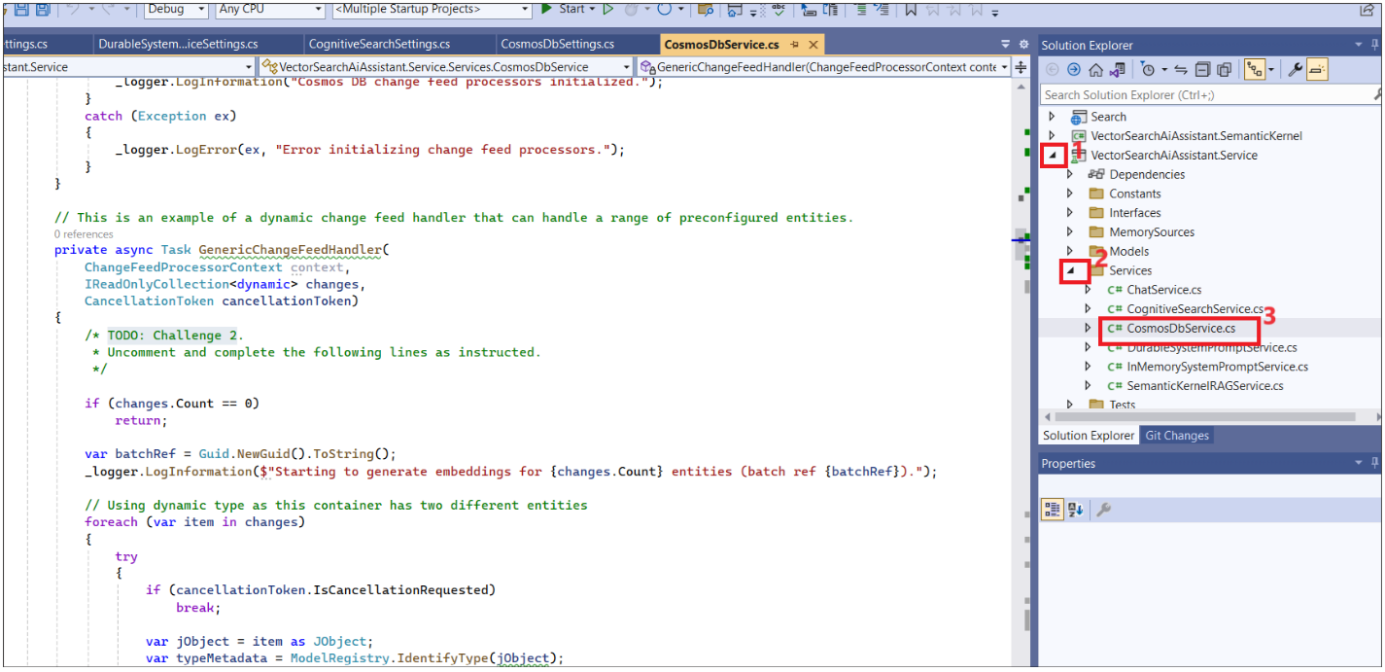

1. Go to the **StartChangeFeedProcessors** function in the code and uncomment the below section as shown in the below images.

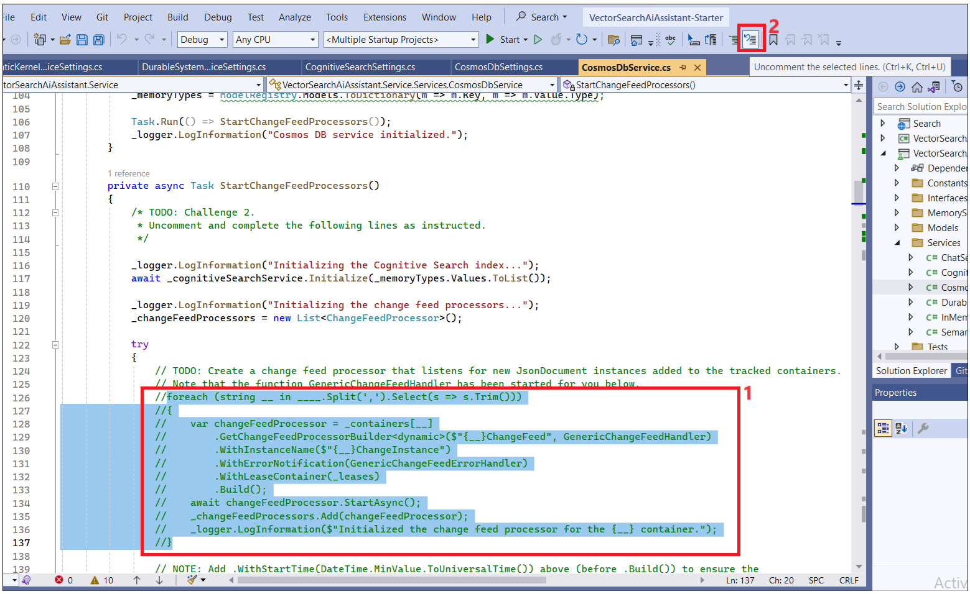

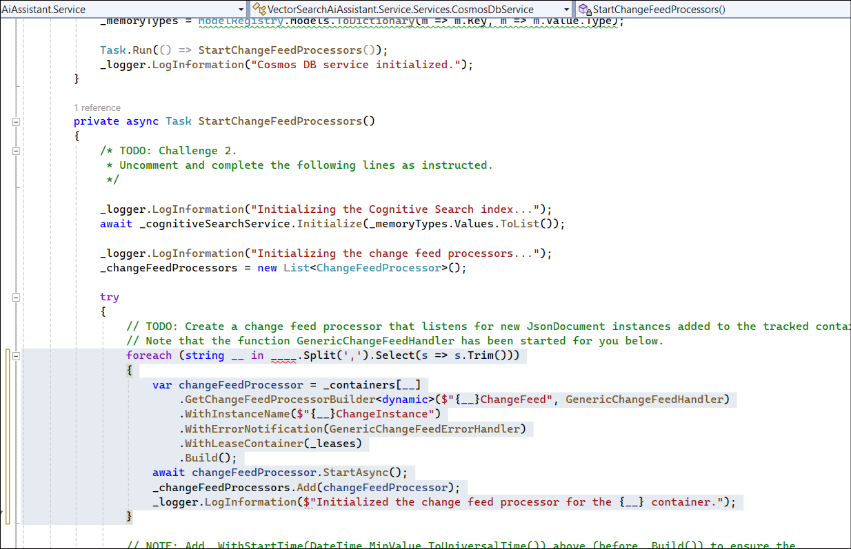

1. Open **appsettings.json** from **ChatServiceWebApis** to verify CosmosDBContainers. MonitoredContainers property will be loaded into the **CosmosDbService.cs** using the settings variable**.**

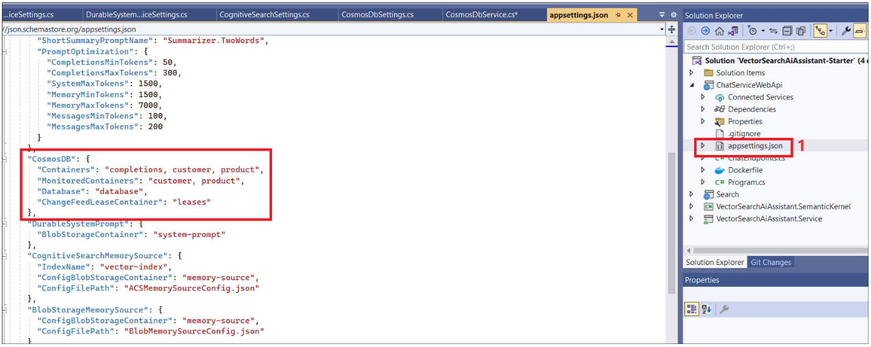

1. Open and update the file **CosmosDbService.cs** with CosmondDb containter settings with _settings.MonitoredContainers to load MonitoredContainers properties as shown in the below images.

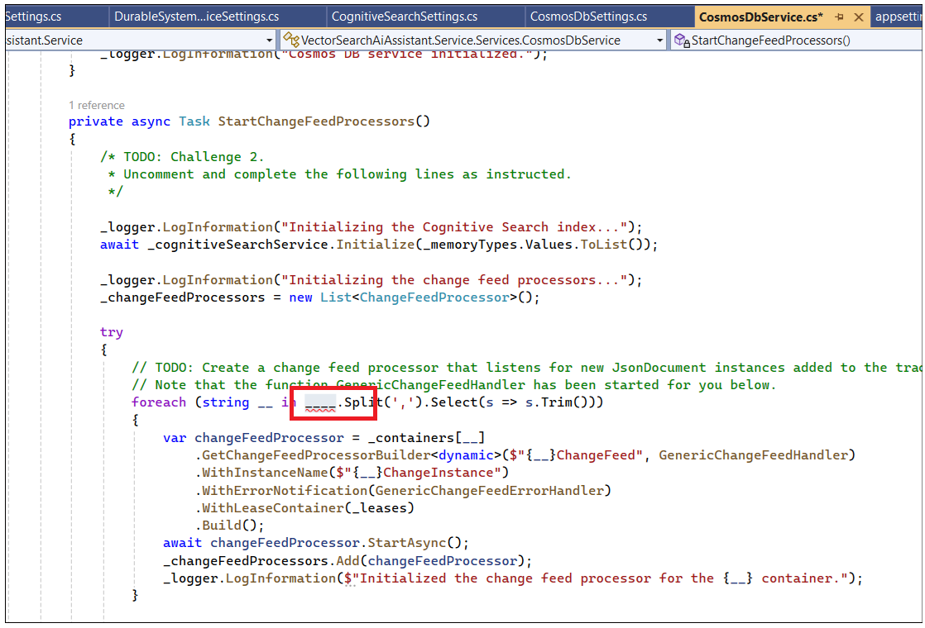

1. The list of monitored containers is provided in the configuration and is mapped to _settings.MonitoredContainers. Replace --- with _settings.MonitoredContainers as shown in the below image.

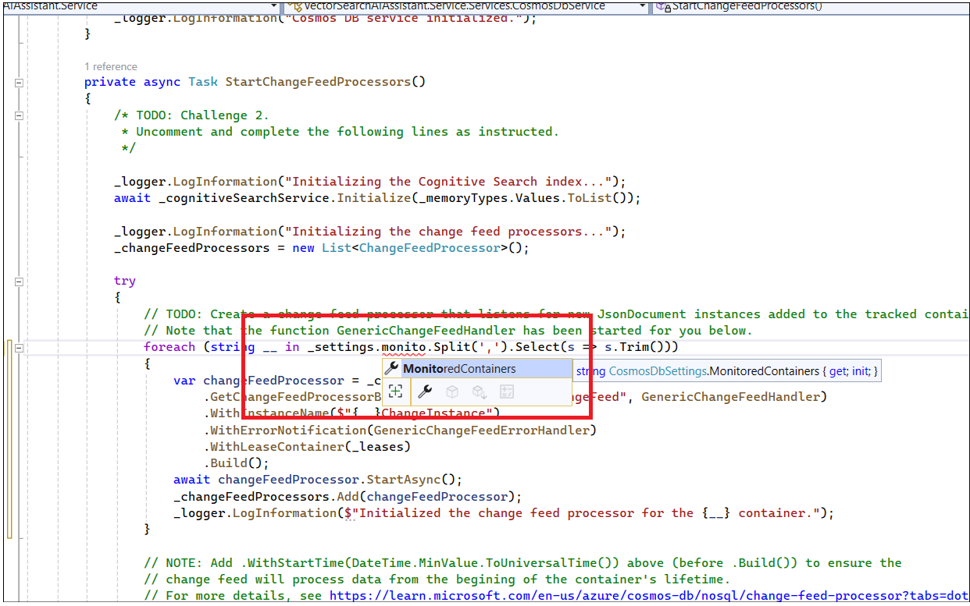

1. Use monitoredContainerName as the name of the iteration variable to iterate containers as shown in the below image. Replace – next to the string with monitoredContainerName

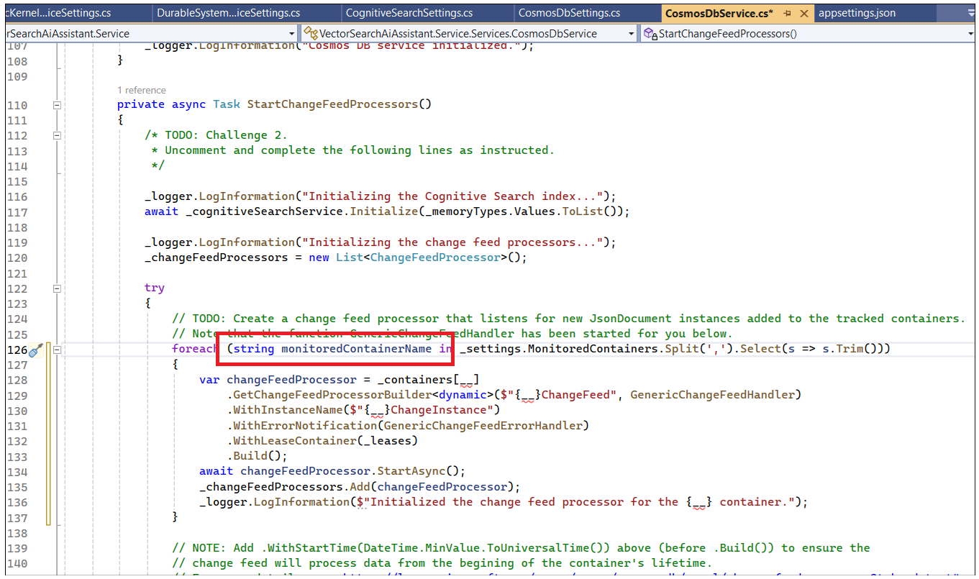

1. Replace --- with monitoredContainerName++ in the below fields as shown in the below image.

changeFeedProcessor = _containers[__] to _containers[monitoredContainerName]

GetChangeFeedProcessorBuilder - $"{__}ChangeFeed" to $"{monitoredContainerName }ChangeFeed"

WithInstanceName($"{__}ChangeInstance") to ($"{monitoredContainerName }ChangeInstance")

_logger.LogInformation.. {__} container. To {monitoredContainerName } container.

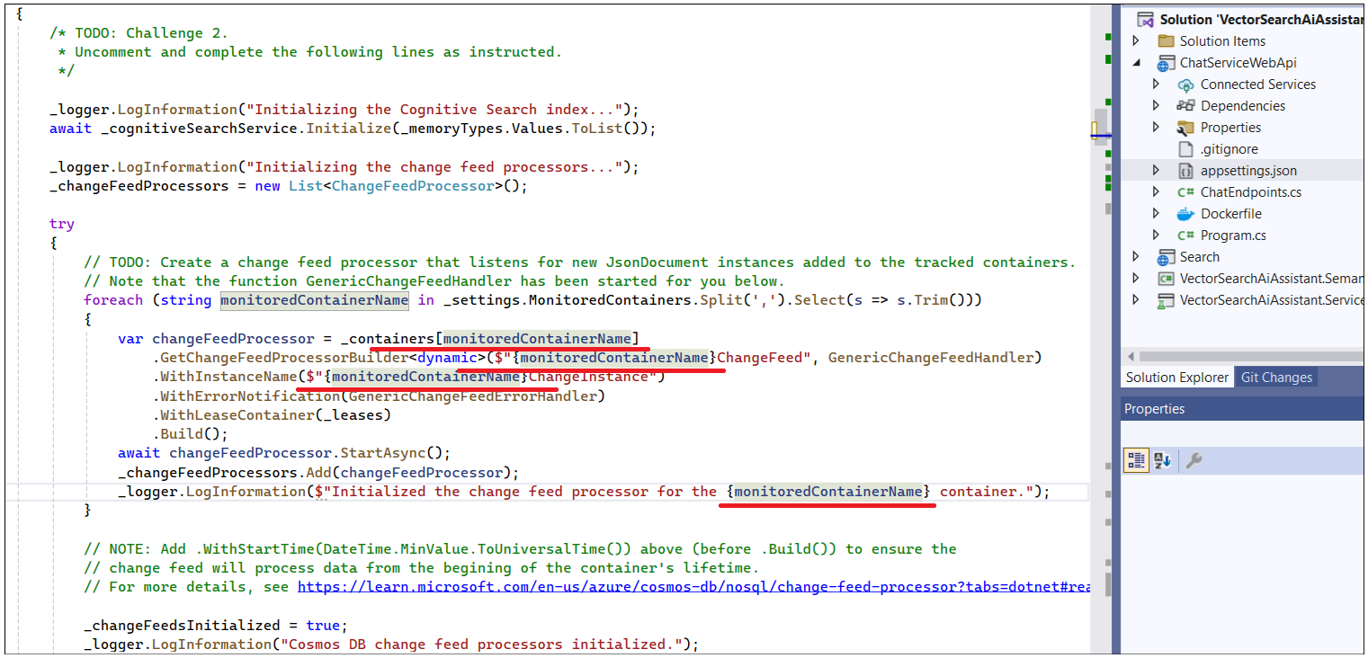

1. Add .WithStartTime(DateTime.MinValue.ToUniversalTime()) before the **Build** to pick up the data from CosmosDB Containers.

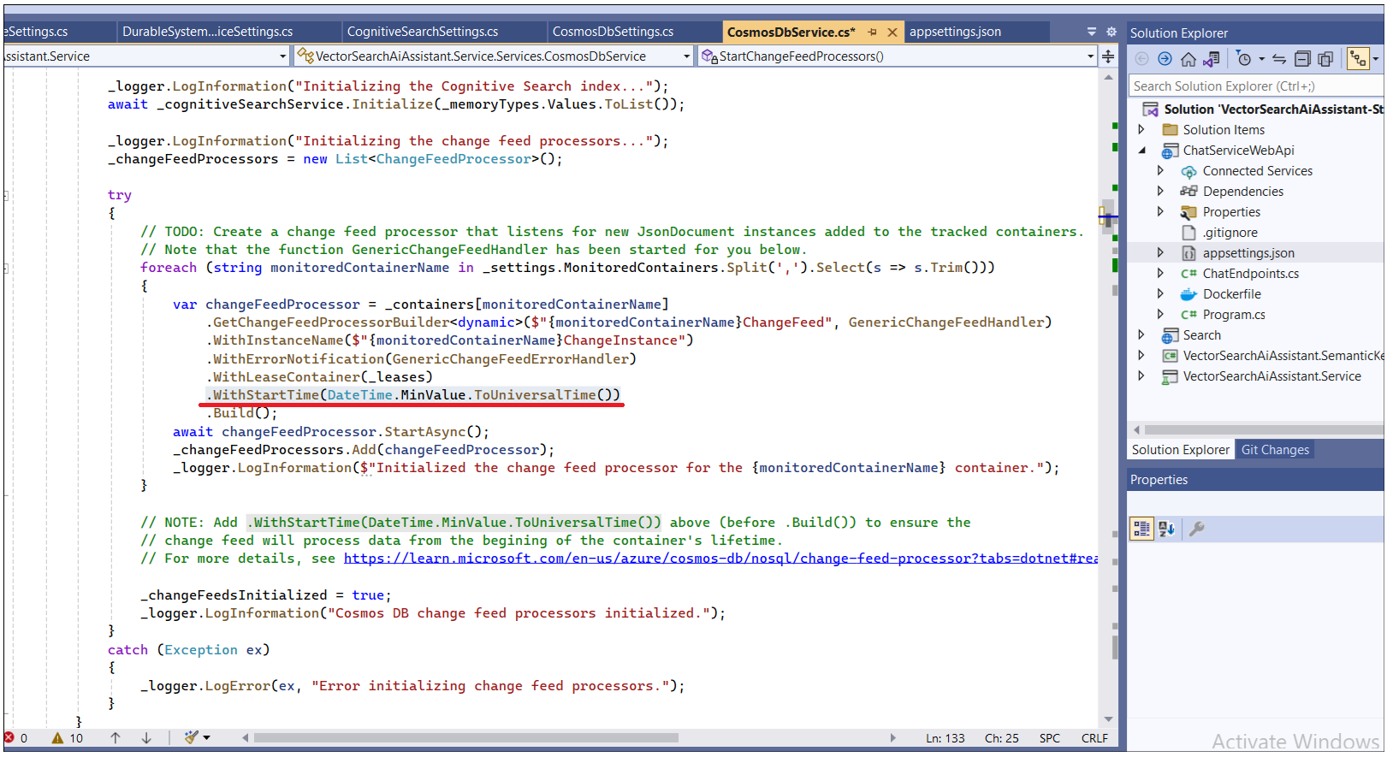

1. Uncomment the **await_ragService** entity and await _cognitiveSearchService.{__}(entity) as shown below

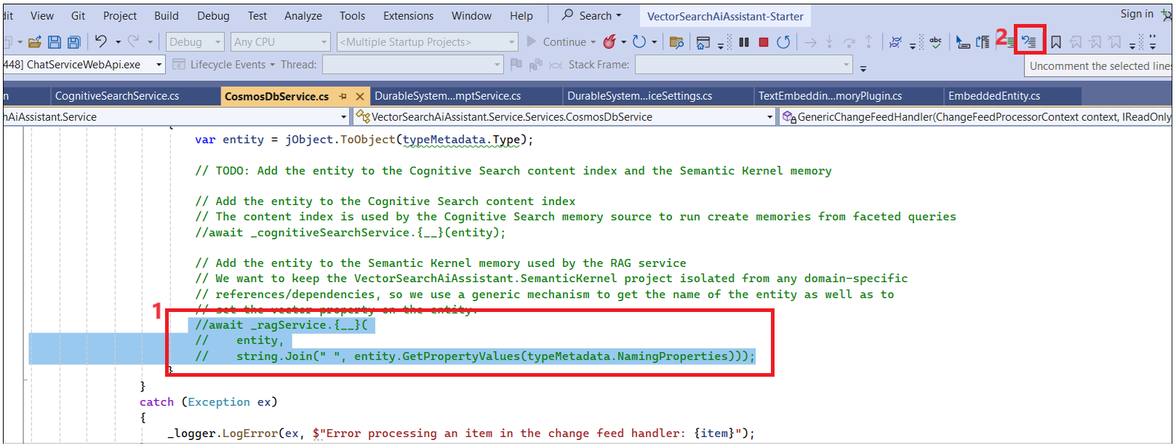

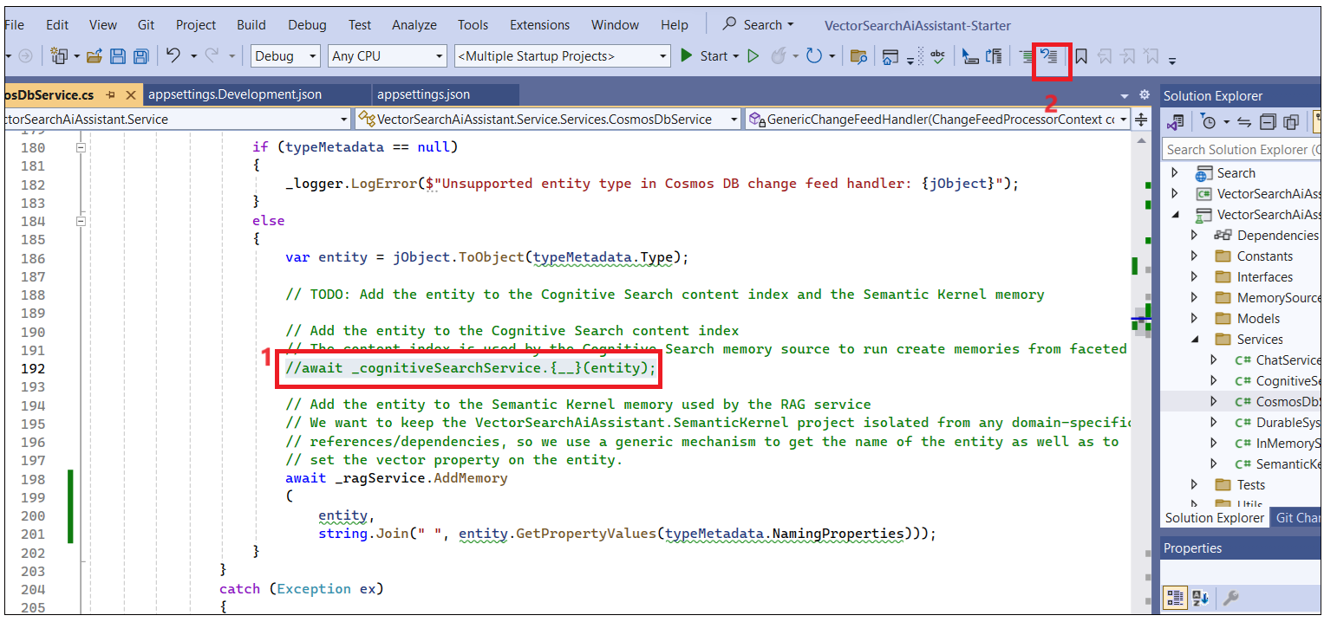

1. Replace { __} in _ragService with AddMemory and replace { __} in _cognitiveSearchService with **IndexItem** **save** the file.

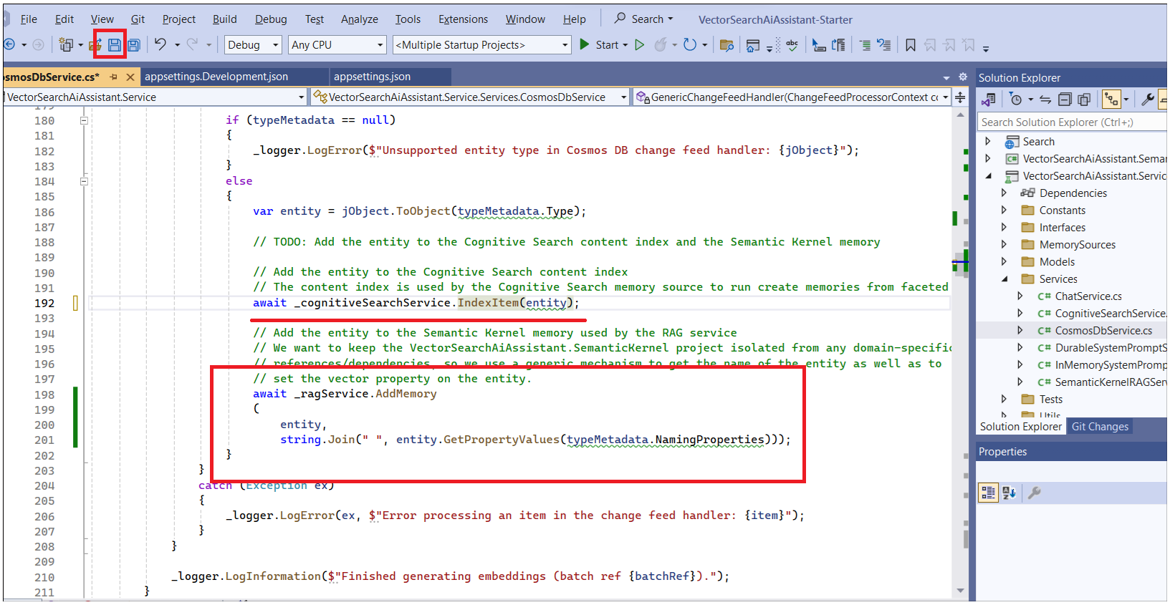

1. Build the solution to start to changefeed service to start processing the data from the CosmosDBContainers, generate the emadeings using the OpenAI embedding models, and insert them into the Cognitive Search index.
2. Click on **Start** to build the solution.

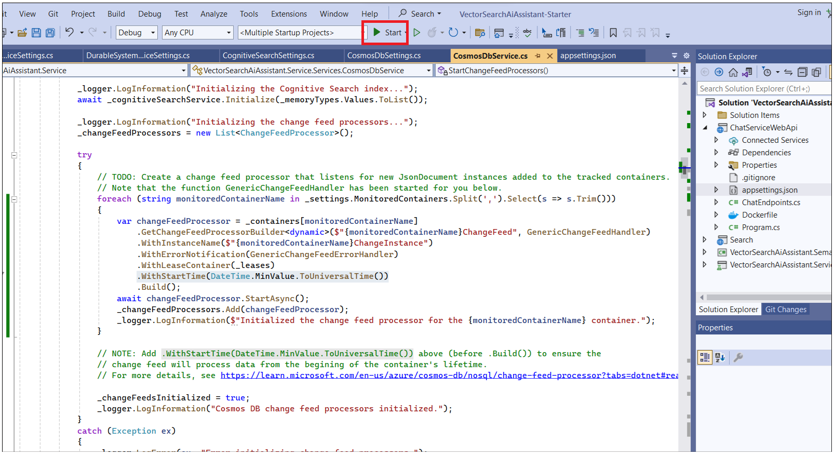

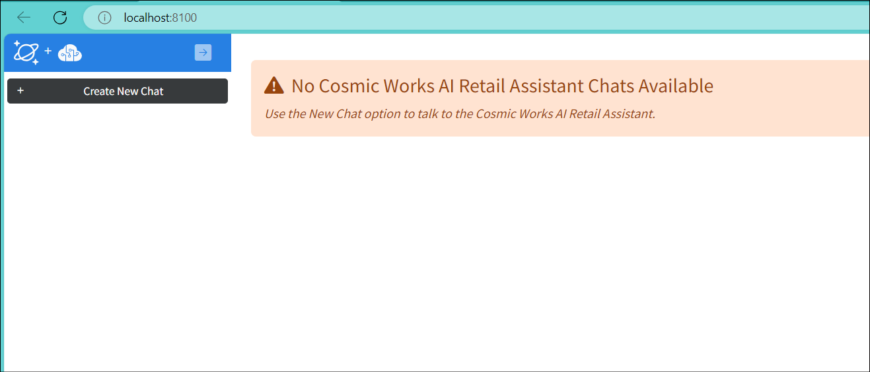

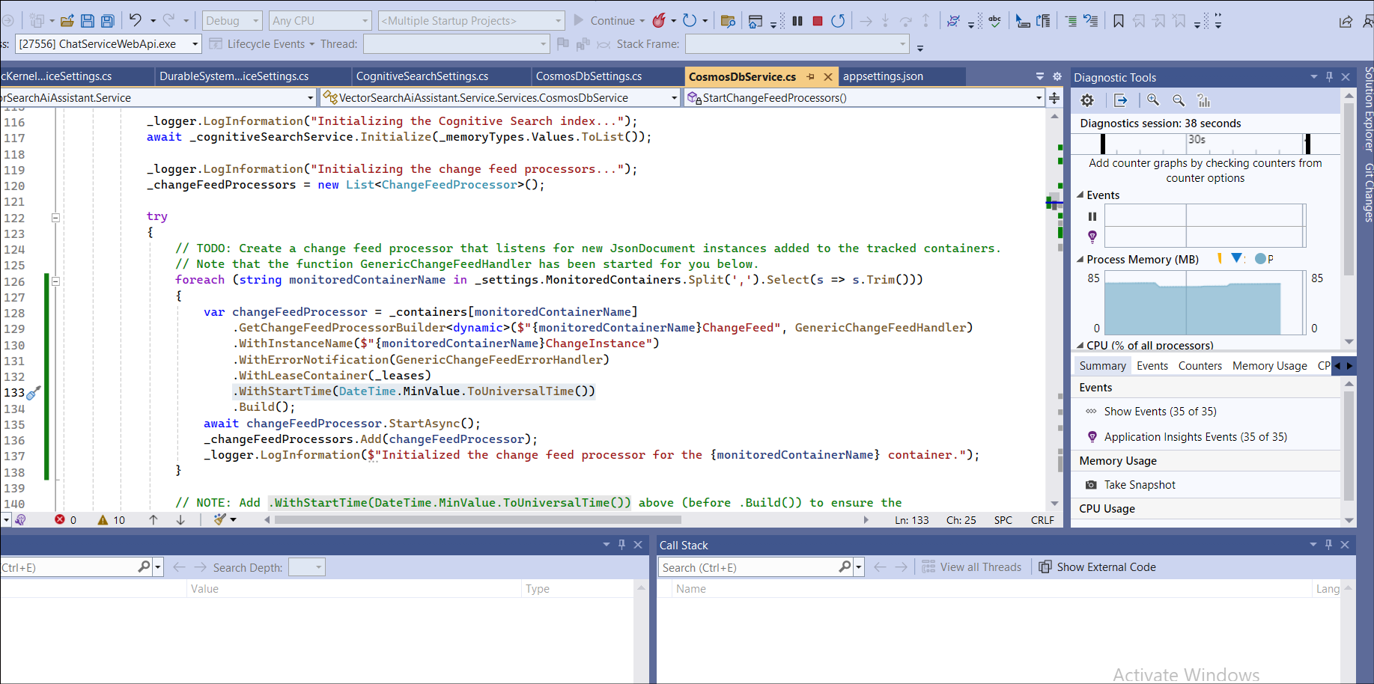

1. This shows the process of the changefeed service where it generates embedding vectors and saves them in Cognitive search. This process takes a 5-10 min.

Note : if the process is not running or taking too long to complete then go to Azure portal-> Cosmos DB- > Data explorer-> leases-> items -> select delete all the items.

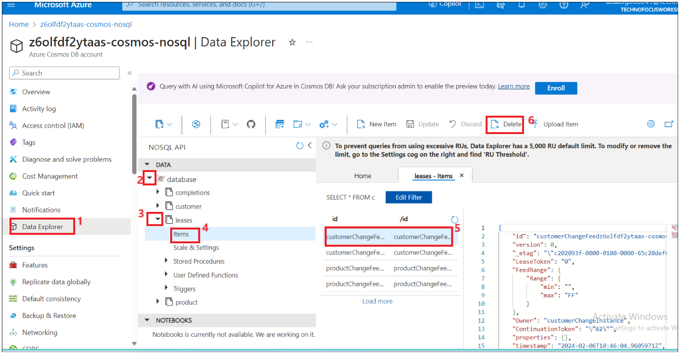

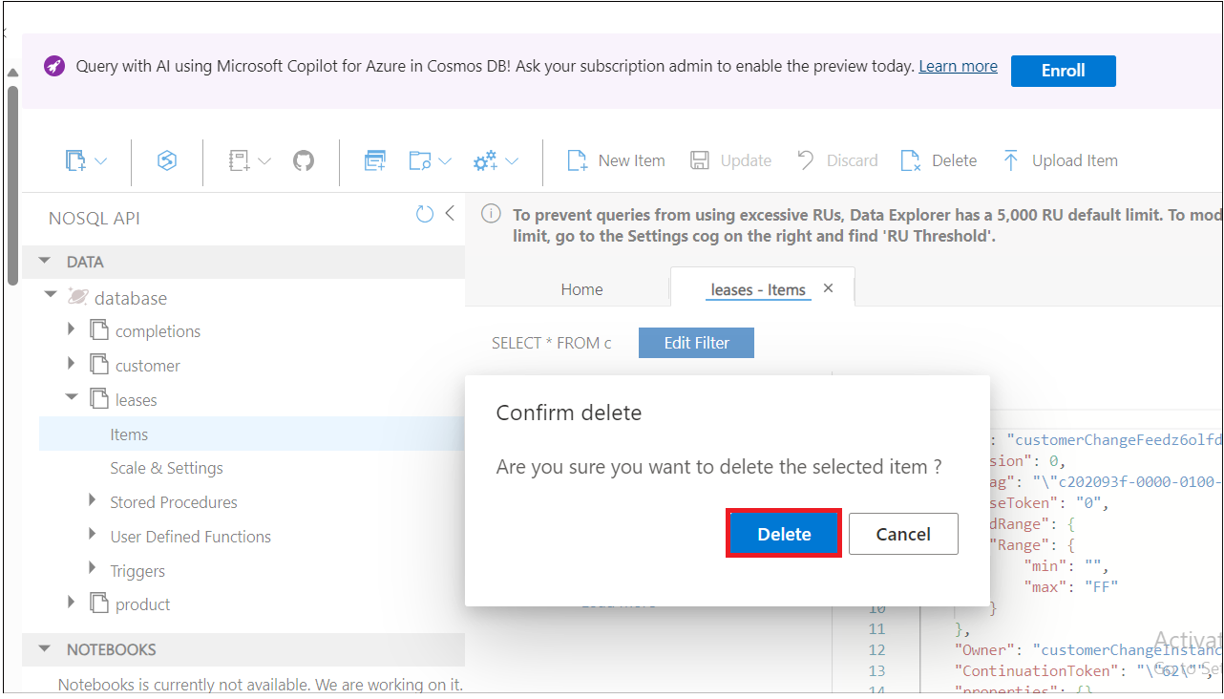

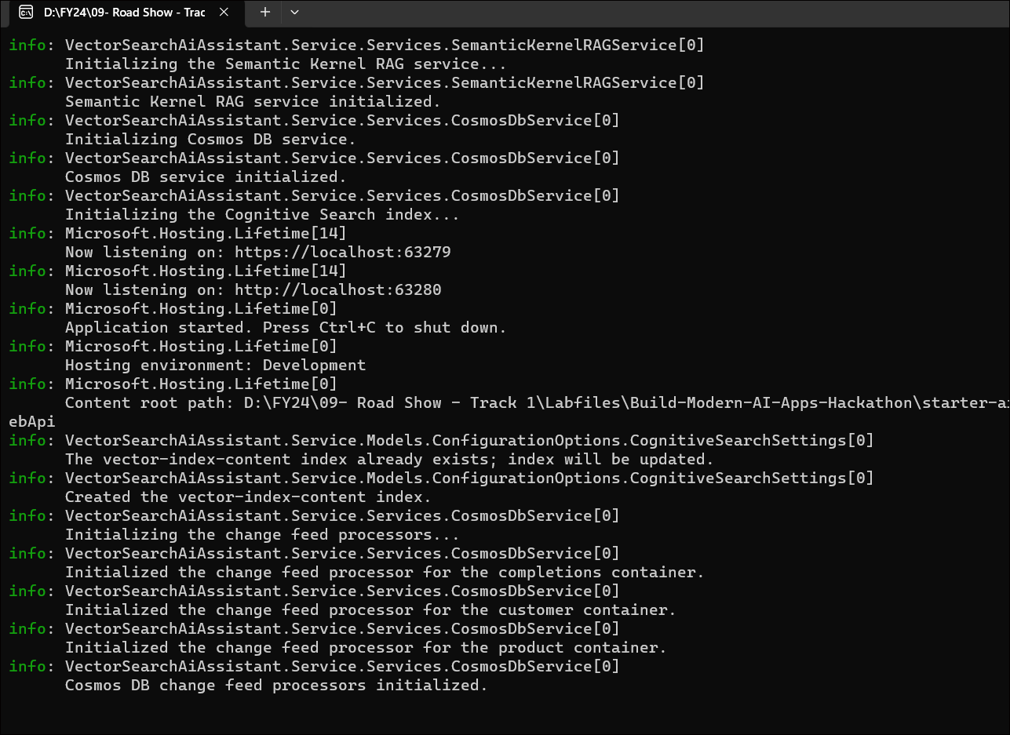

1. Once the solution is built. you can see information log on the console ,created a vector index and initialized change feed process for customer, product containers.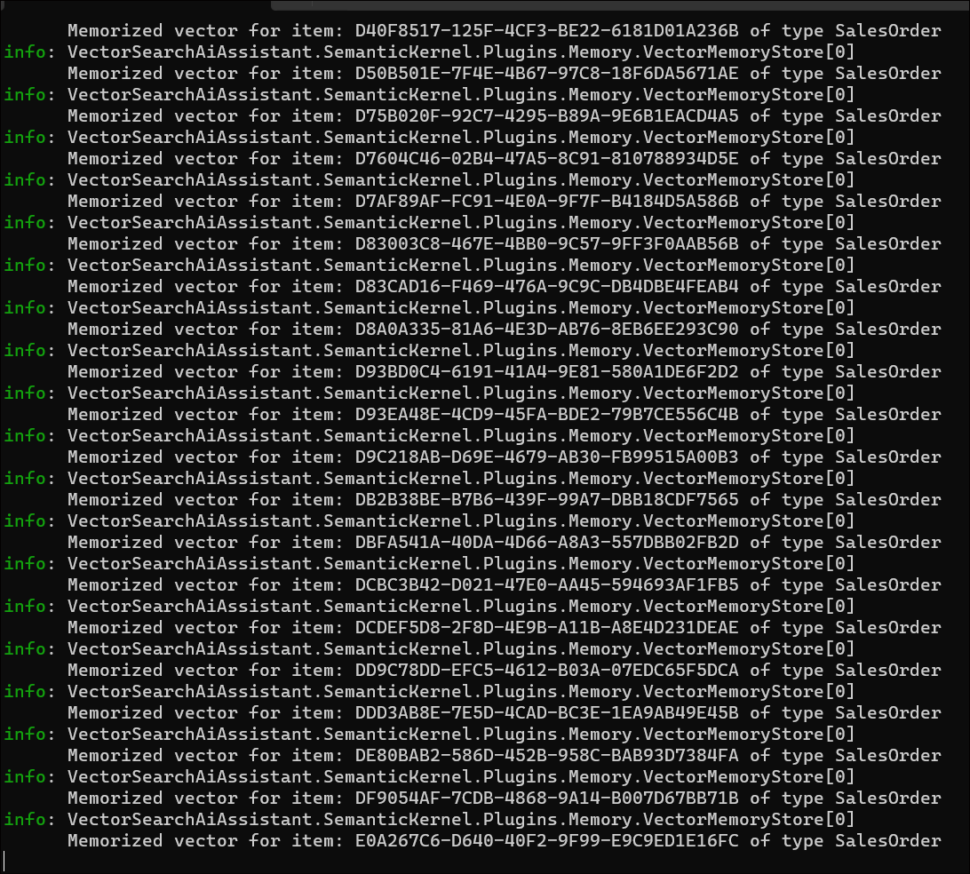
2. Wait until the change feed process completes its operation. Once the process is complete then you should see a message **“Finished generating embeddings**” message. This means the change feed service has picked up all the items in **Cosmos DB** containers generating the embeddings using OpenAI model and then storing them in **Cognitive search.**

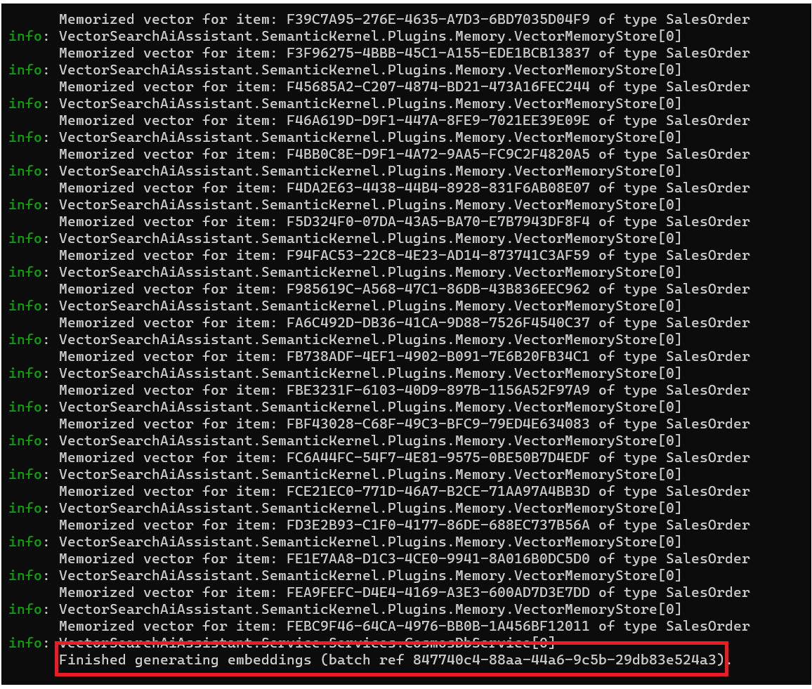

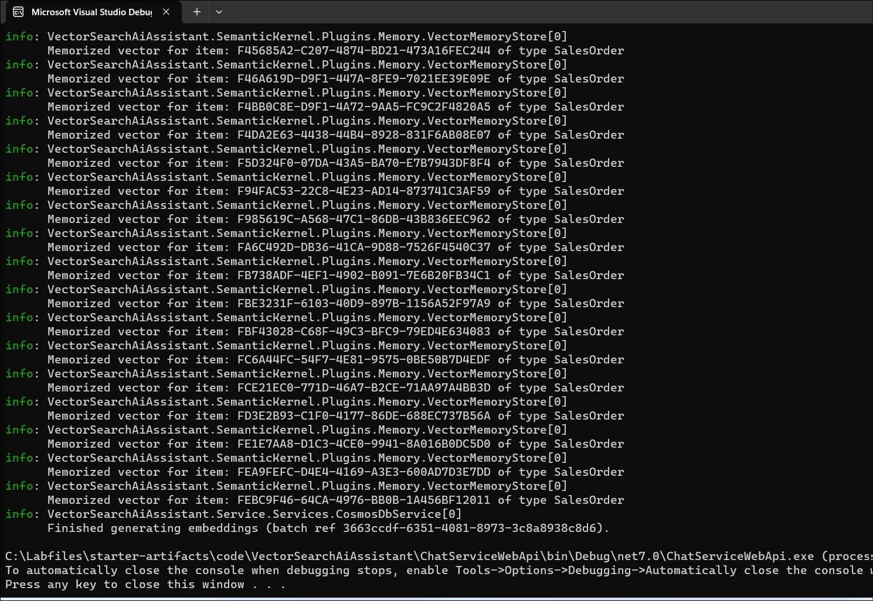

1. Go back to the **Azure portal** click on your resource group name and then click on the **Azure AI search service** name.

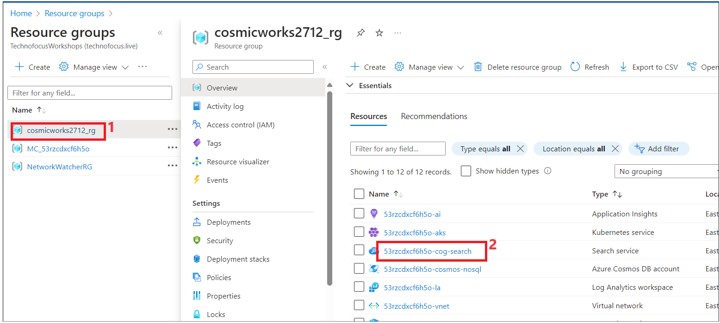18. From the left navigation menu, click on **index** under **Search management**. You should see **1879** documents loaded into an **index** and the size of the index is 1.48 MB.

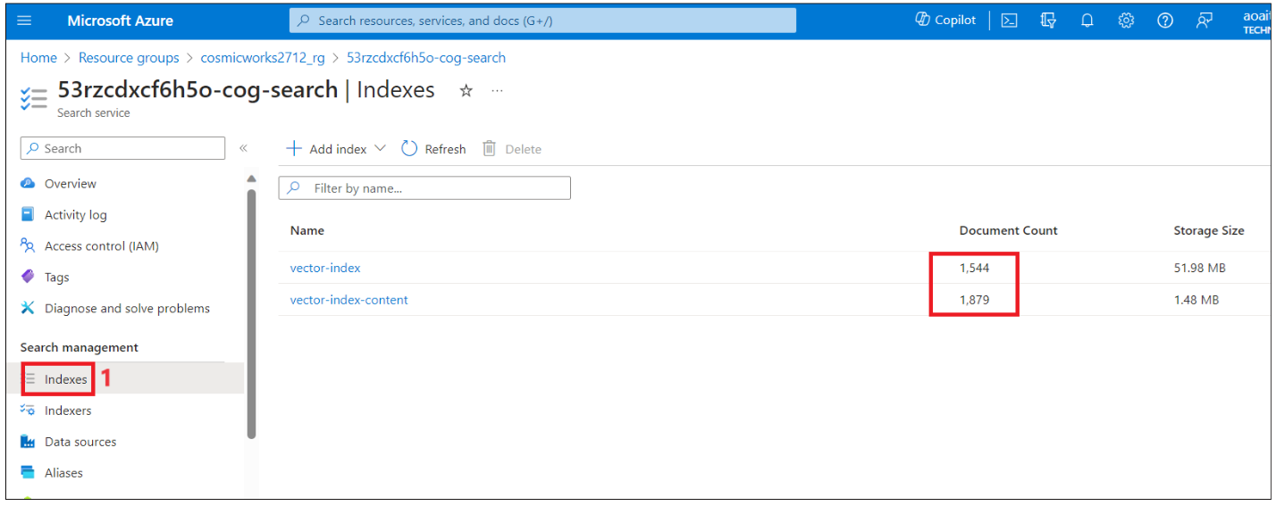

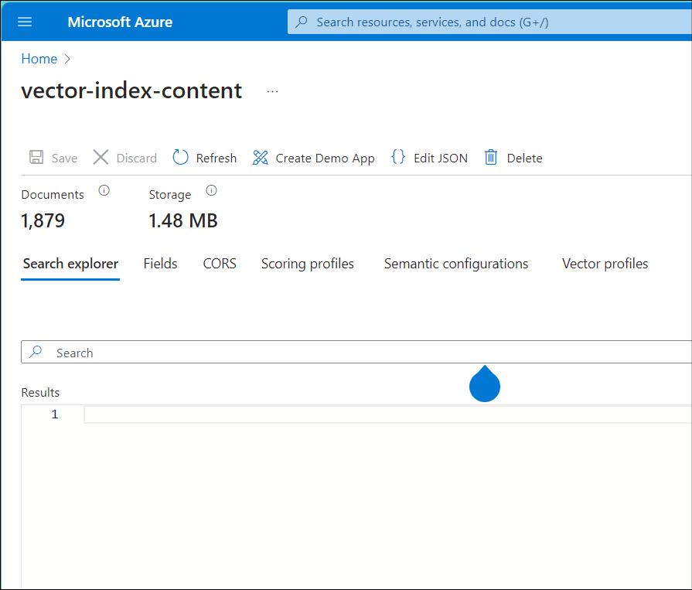

1. Click on **Vector-index-content**

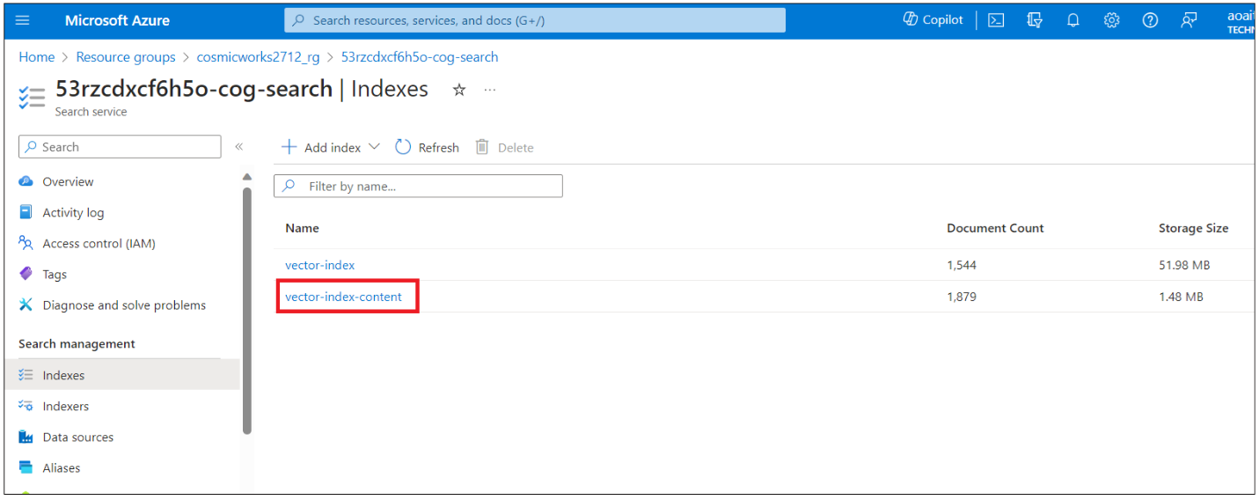

1. Enter star(*) and then click on **Search**. You should see the documents return .

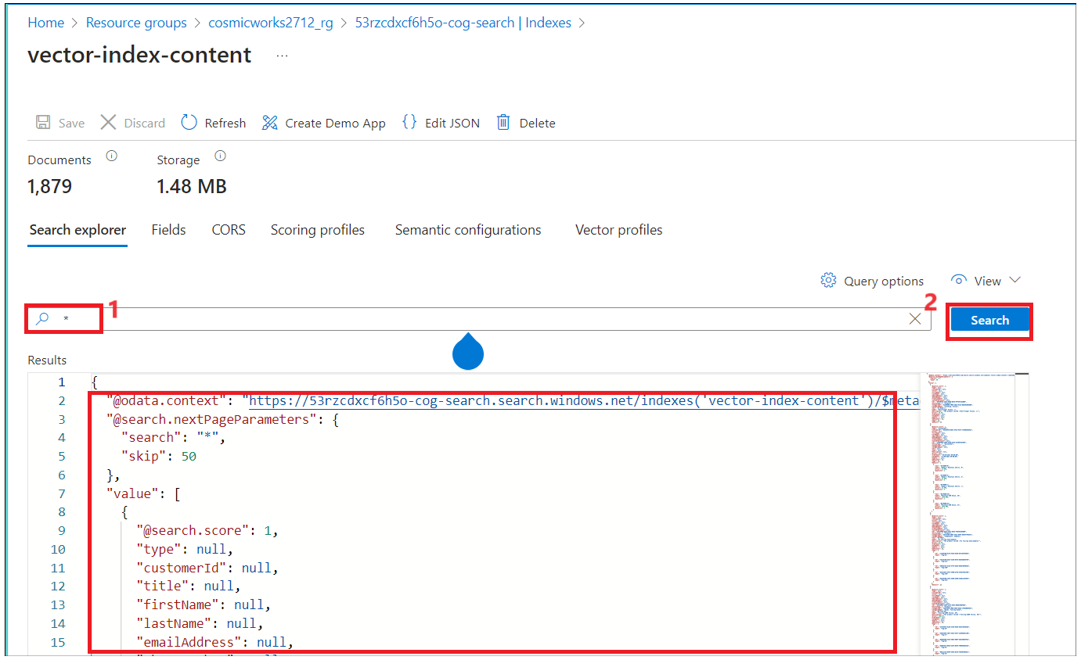

1. You can see Customer values null and scroll down to see product details as the document is related to the product.

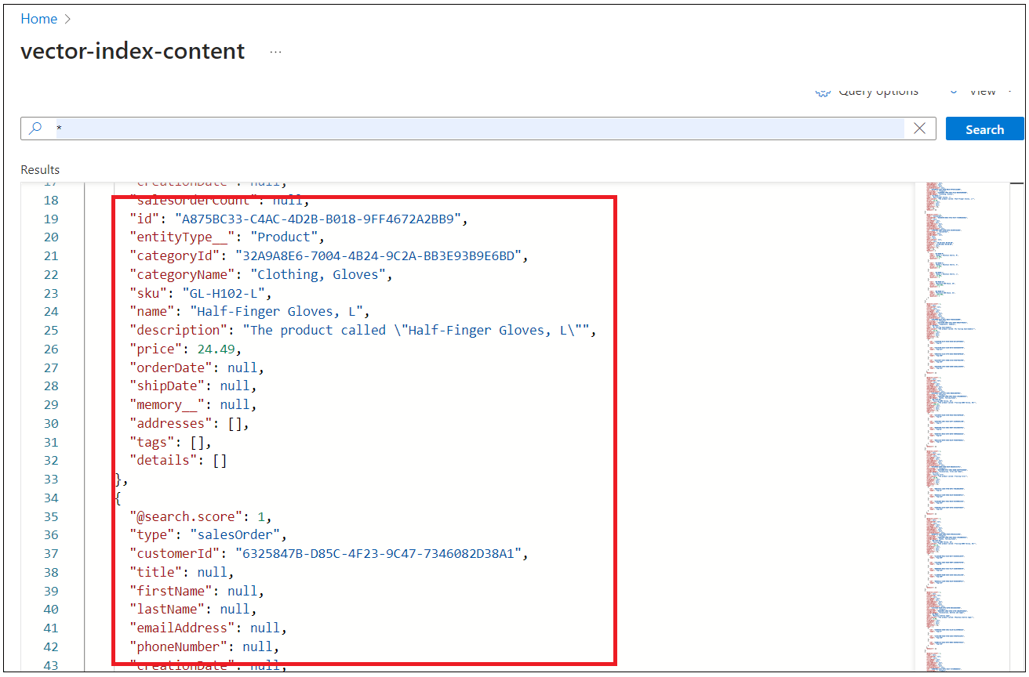

20 . You can see the configuration of the vector index created for you. You can see all the fields customer, product etc.

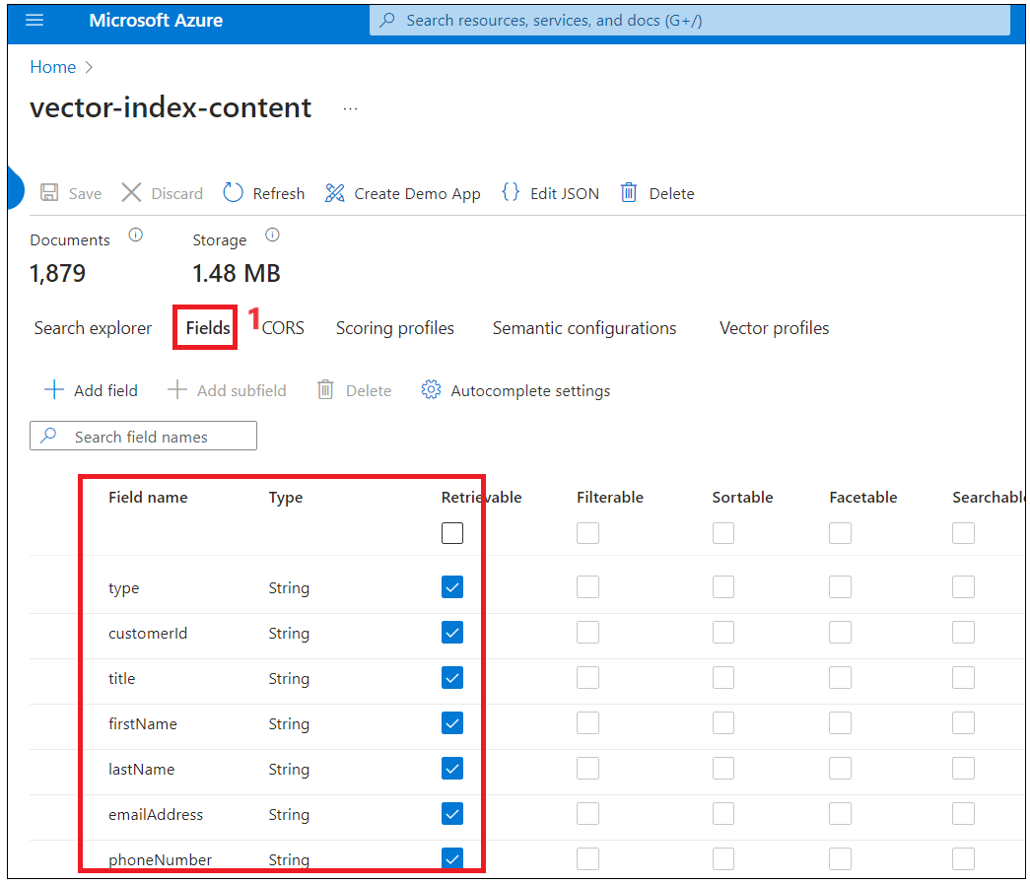

1. Click on **Index** on the top navigation menu as shown in below image.

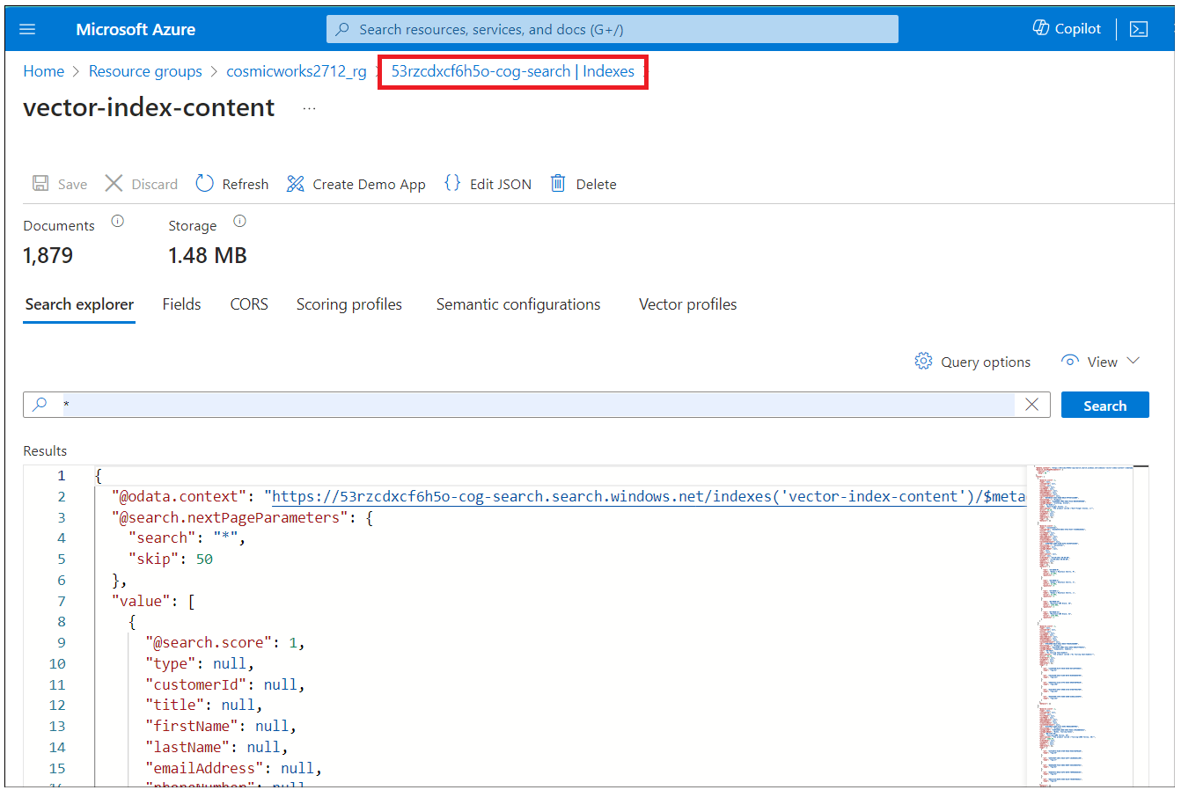

1. Click on **Vector-index** which has 1544 documents loaded.

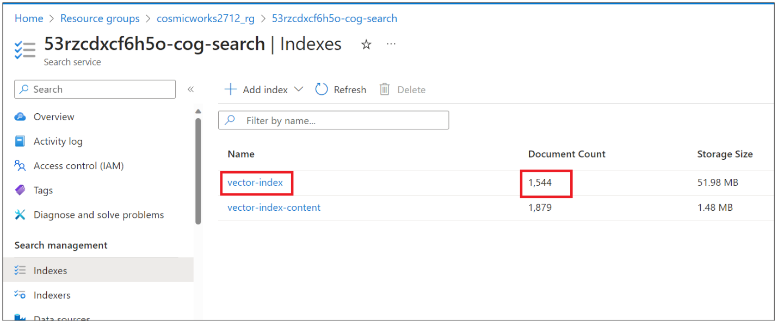

1. Select * and click on **Search** to see vectors generated for embeddings. Vector embeddings are numerical representations of the text on which we have generated embeddings.

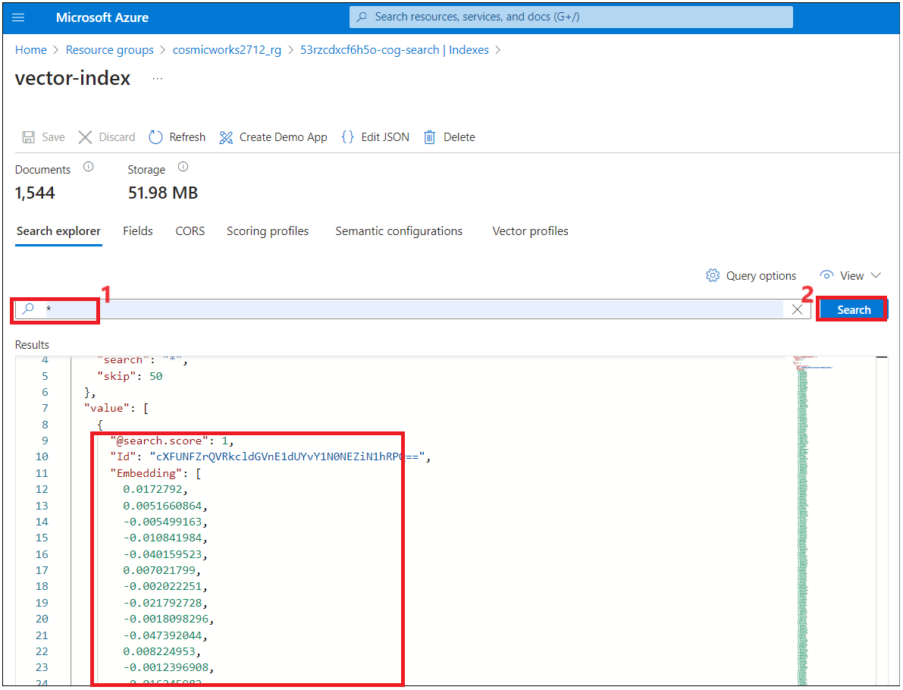**Summary**

• We loaded the data from the storage account into Cosmos DB using a method that can be repeated in the future.

• Performed a document count on each container in Cosmos DB and verified that the counts matched the number of documents in the storage account.

• Generated vector embeddings of a sufficiently high dimensionality that is supported by the Azure OpenAI service as well as your vector database.

• Encapsulated the embedding logic within a service layer that can be used by other components of the CosmicWorks chat interface, as well as a future REST API service.

• Created a process that automatically generates vector embeddings for all of the products and customers in the Cosmos DB database and stores them in the vector database.

• We are successfully able to search for products and customers by vector embeddings.